# Product Design

Note: This is the final prototype of the product design (created by Polina Stoyanova). It uses the framework materializecss applying Google Material Designs principles for mobile-first responsive implementation.

TO DO:

* staff dashboard
* authorised staff dashboard
* reports
* document colour, font, font size, element dimensions

Initial wireframes as well as previous prototype iterations are added as appendices.

Table of Contents

Product Design 1

1. Login screen 3

a. Tablet and desktop 3

b. Mobile 4

2. Login screen validation 5

a. Tablet and desktop 5

b. Mobile 6

3. Student dashboard 7

a. Messages 7

b. Meetings 11

c. Blog/diary 15

d. Uploads 19

Appendices 27

Appendix A – Workflows by Kinza Naseer 27

Appendix B – Design Principles by Laura Whitehead 28

Appendix C – Responsive Web Design by Andrew Tate 35

Appendix D - Initial wireframes by Kinza Naseer and Sumangalya Mohanarasa 37

Appendix E – Initial prototype by Kinza Naseer 45

1. Login screen
   1. Tablet and desktop

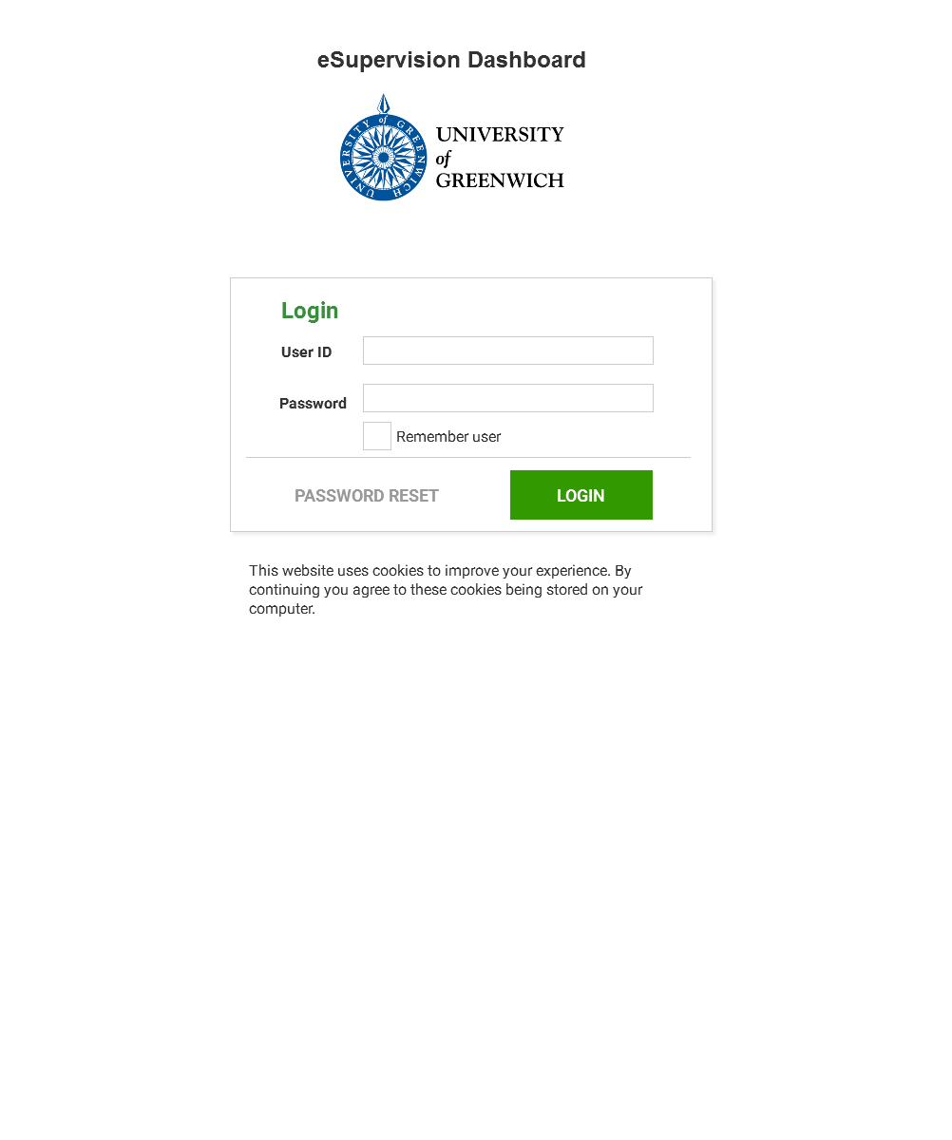

* 1. Mobile

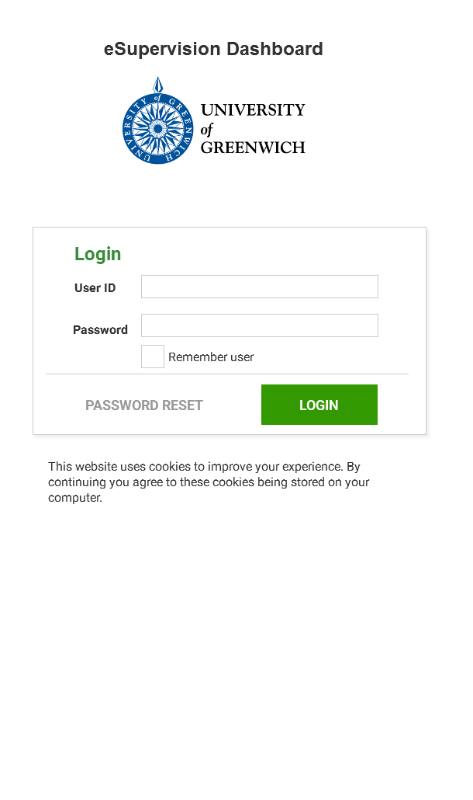

1. Login screen validation
   1. Tablet and desktop

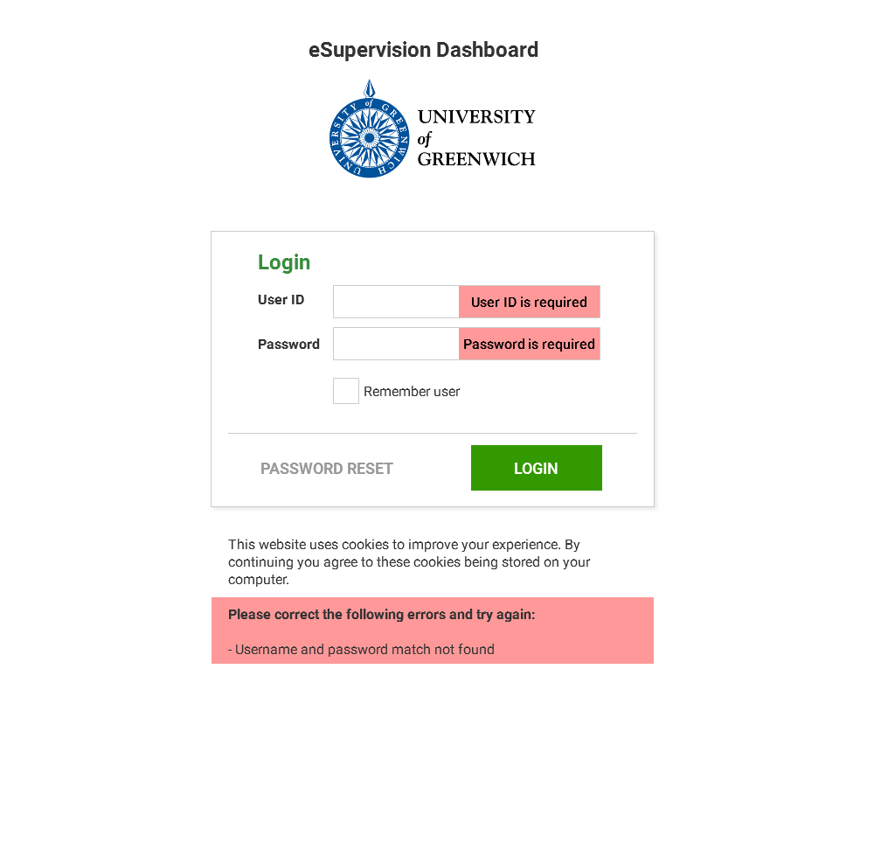

* 1. Mobile

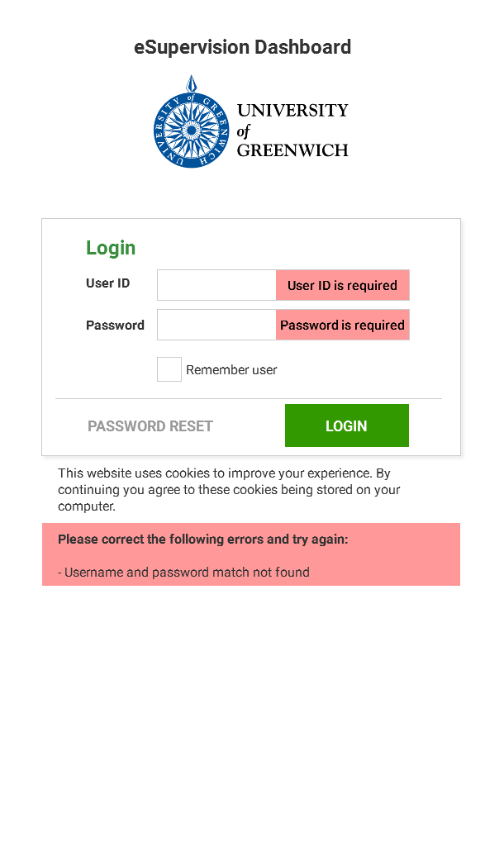

1. Student dashboard
   1. Messages
      1. Messages tablet and desktop

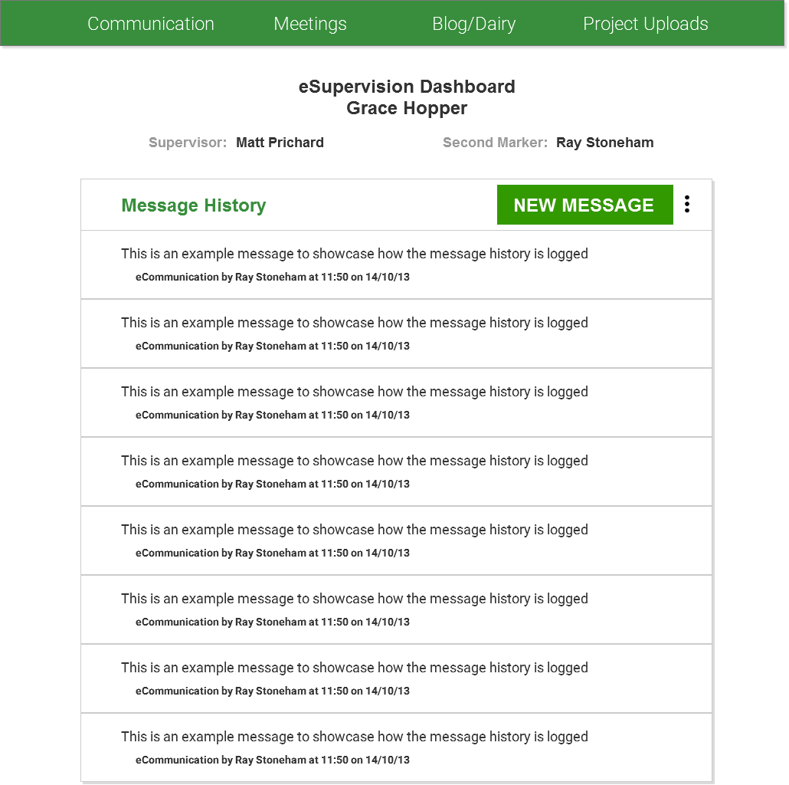

* + 1. Messages mobile

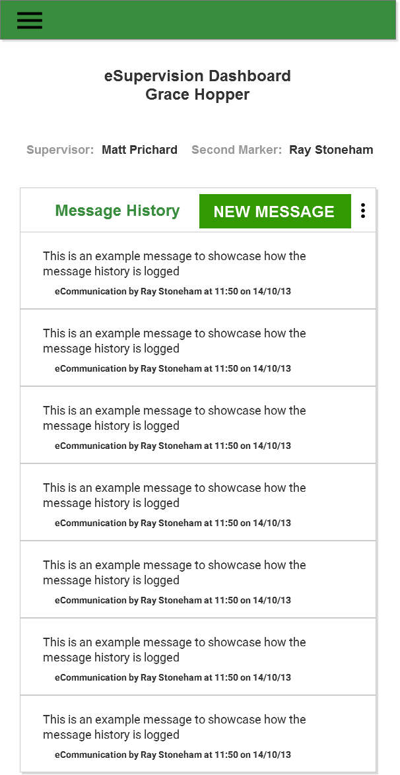

* + 1. Add Messages tablet and desktop

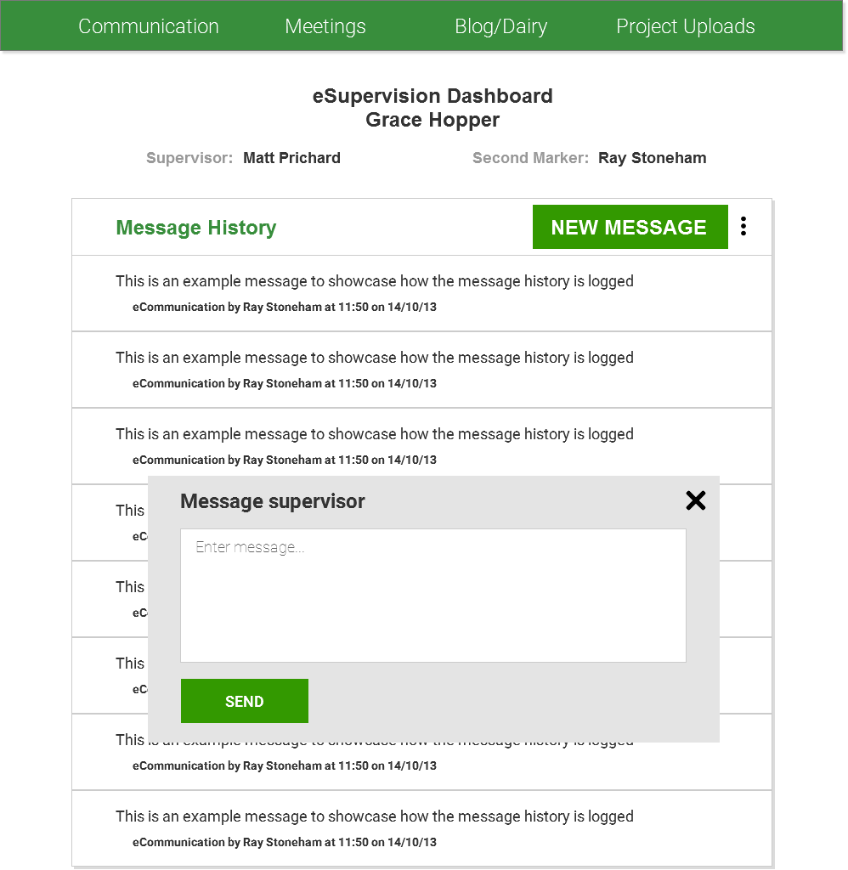

* + 1. Add Messages mobile

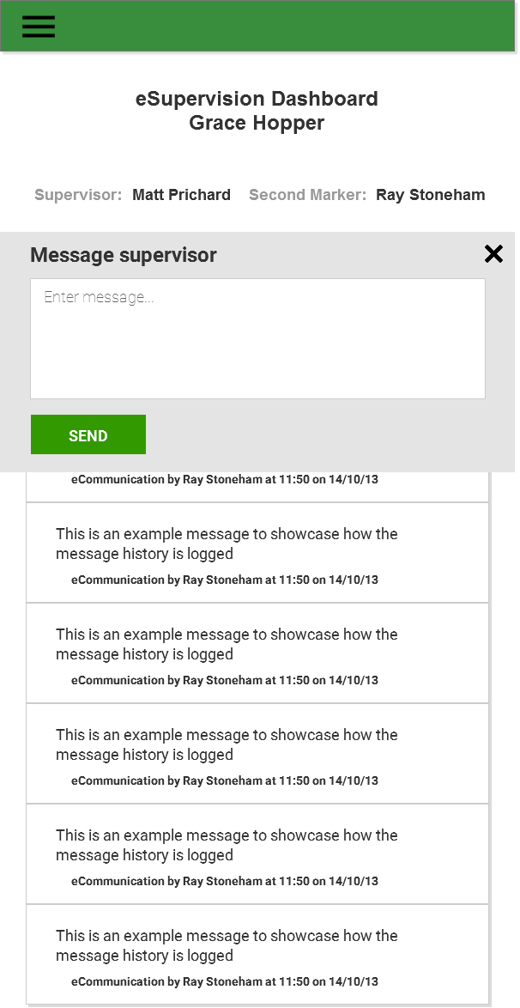 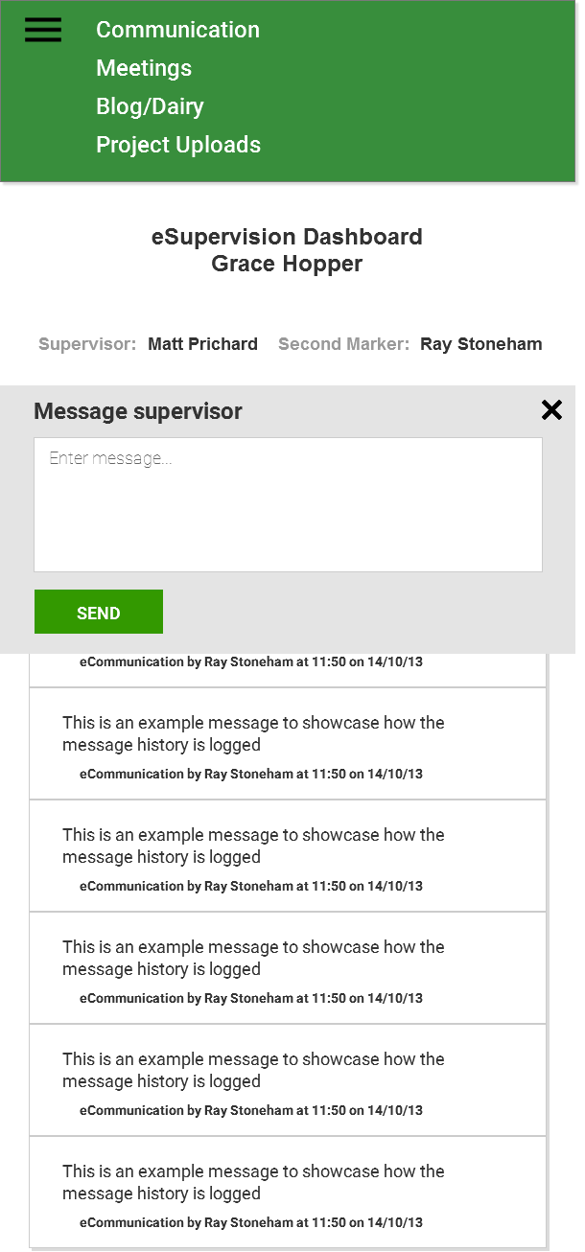

* 1. Meetings
     1. Meetings tablet and desktop

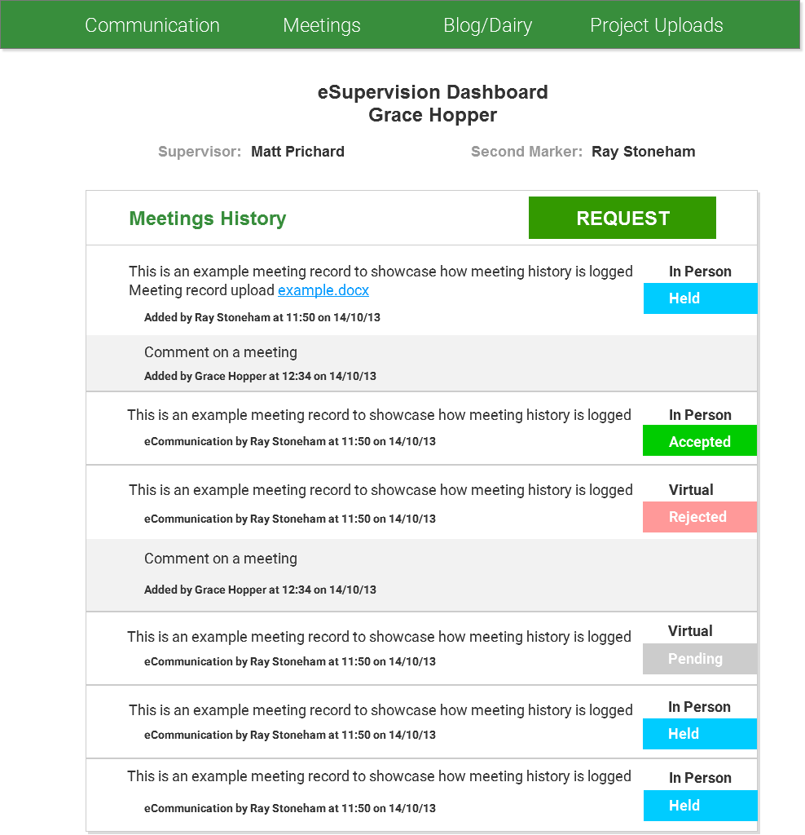

* + 1. Meetings mobile

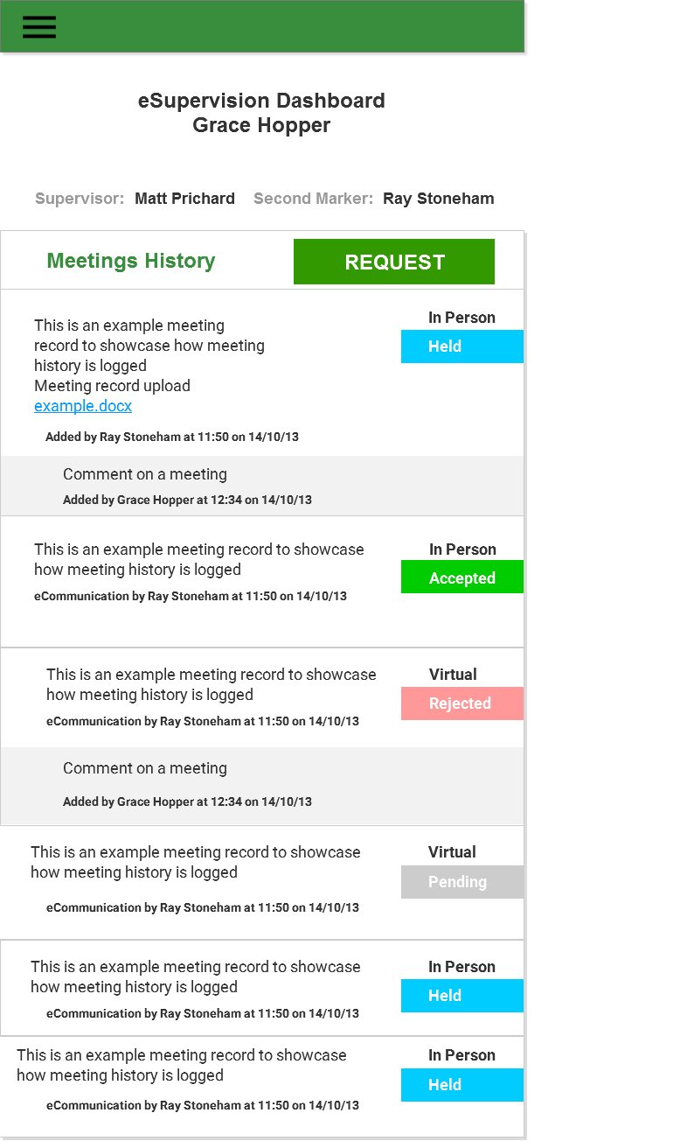

* + 1. Add Meetings tablet and desktop

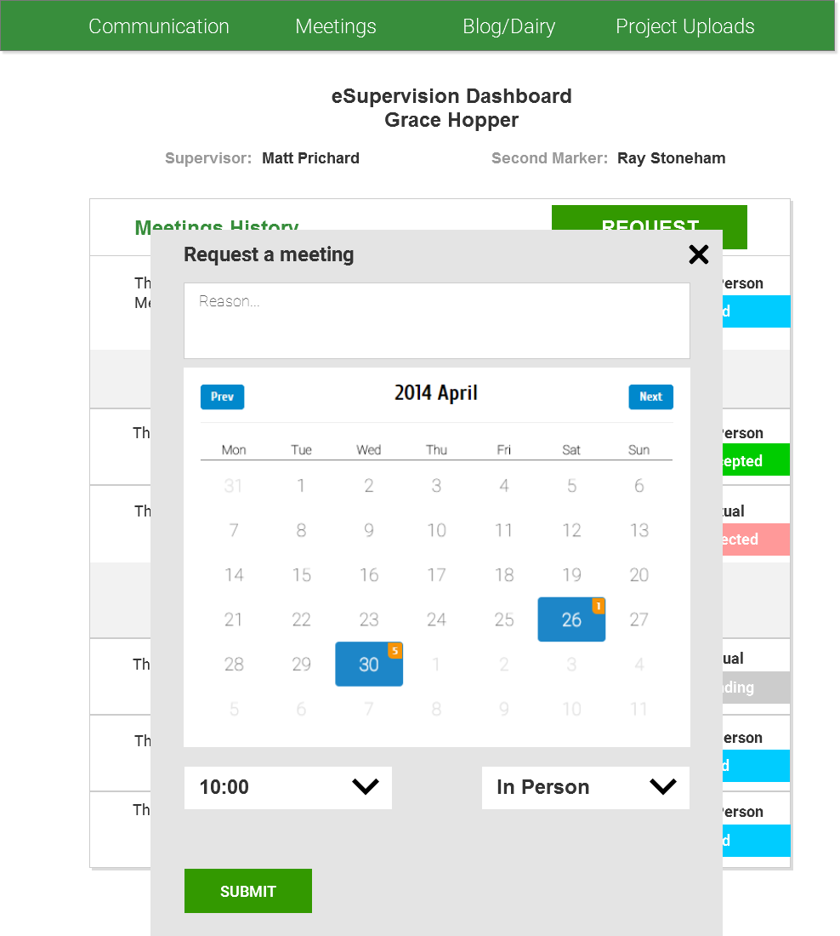

* + 1. Add Meetings mobile

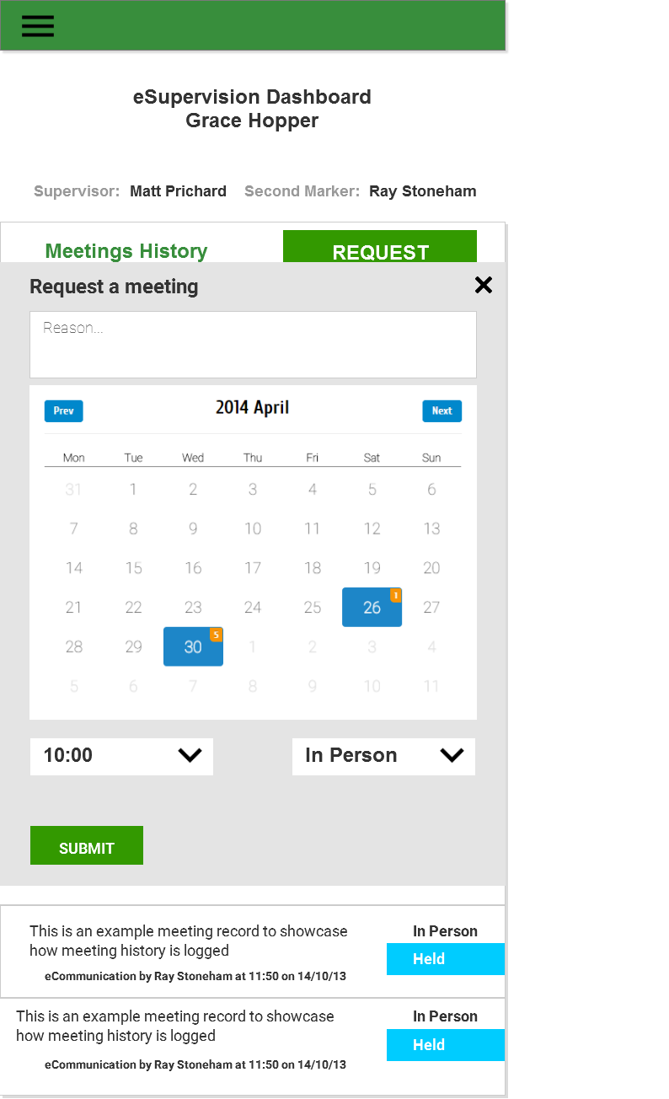

* 1. Blog/diary
     1. View Blog tablet and desktop

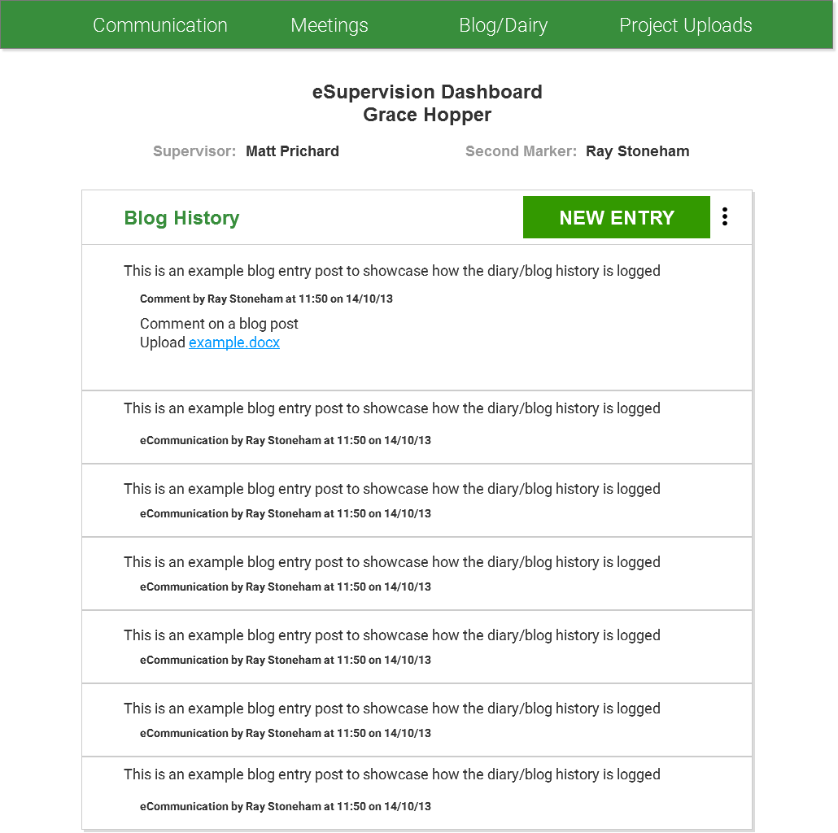

* + 1. View Blog mobile

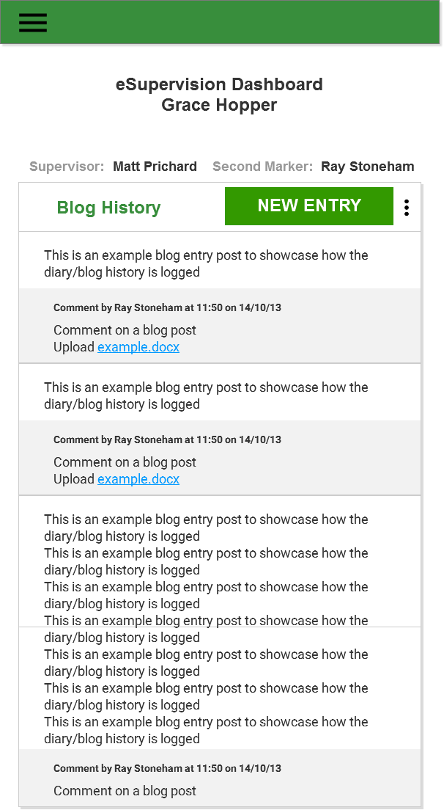

* + 1. Add Blog Entry tablet and desktop

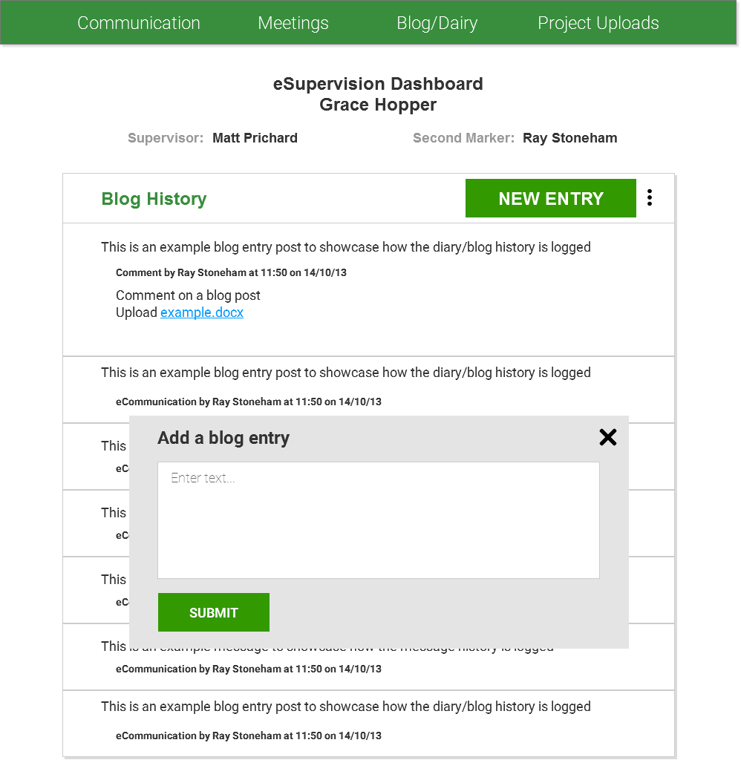

* + 1. Add Blog Entry mobile

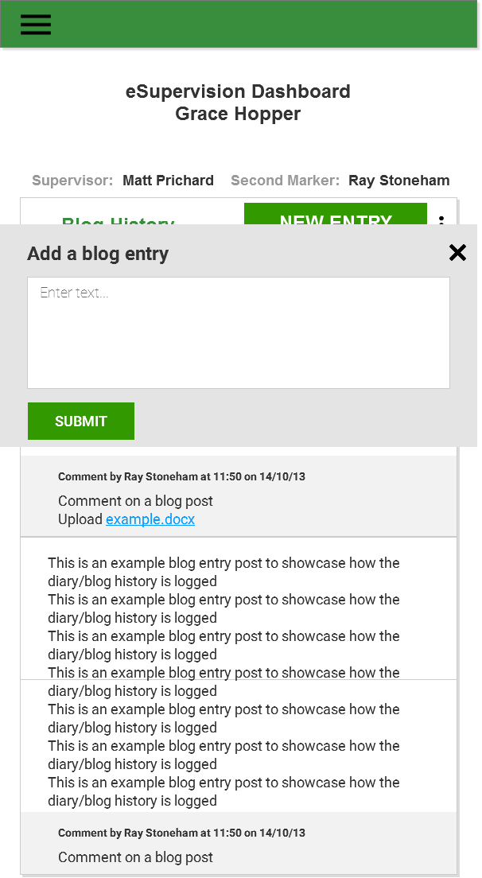

* 1. Uploads
     1. View Uploads tablet and desktop

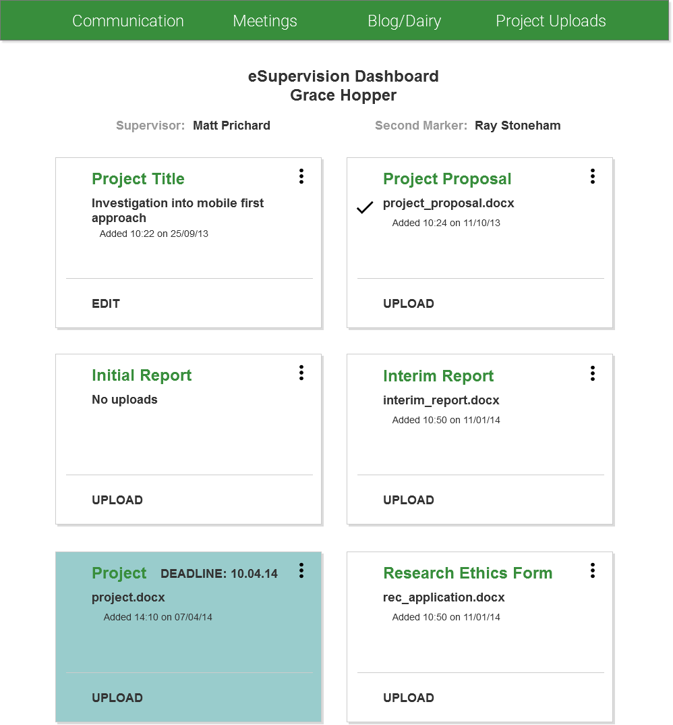

* + 1. View Uploads mobile

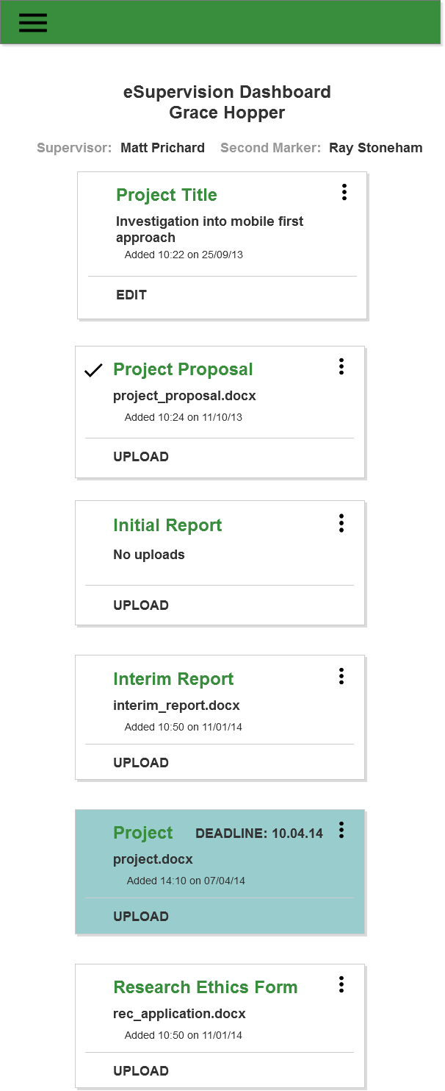

* + 1. Edit Uploads tablet and desktop

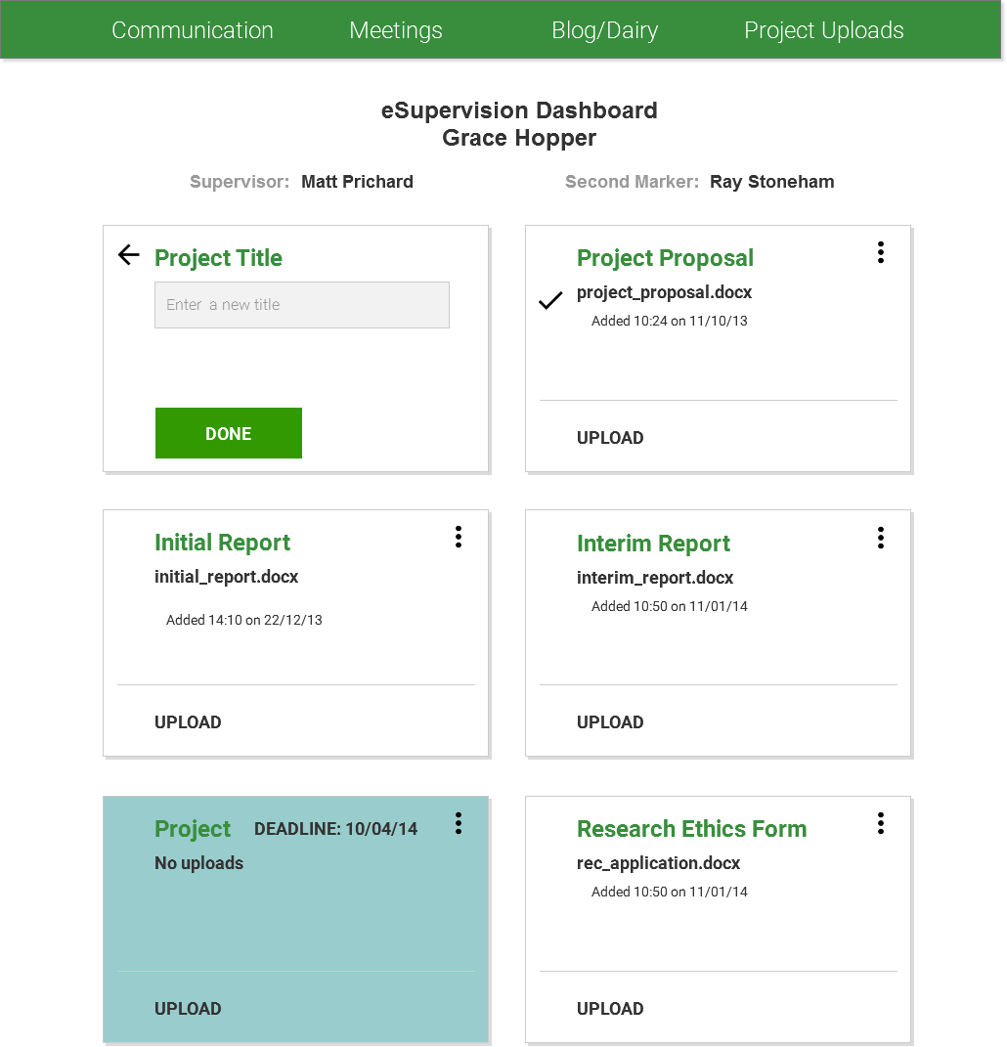

* + 1. Edit Uploads mobile

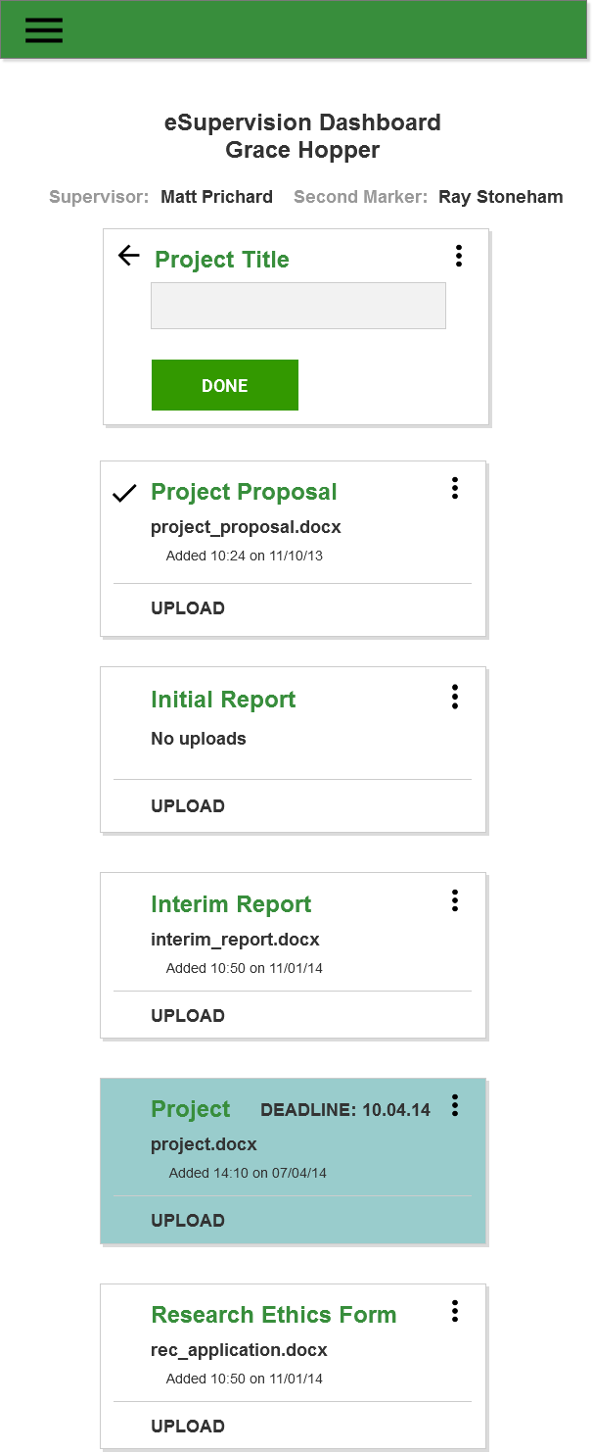

* + 1. More Info Uploads tablet and desktop

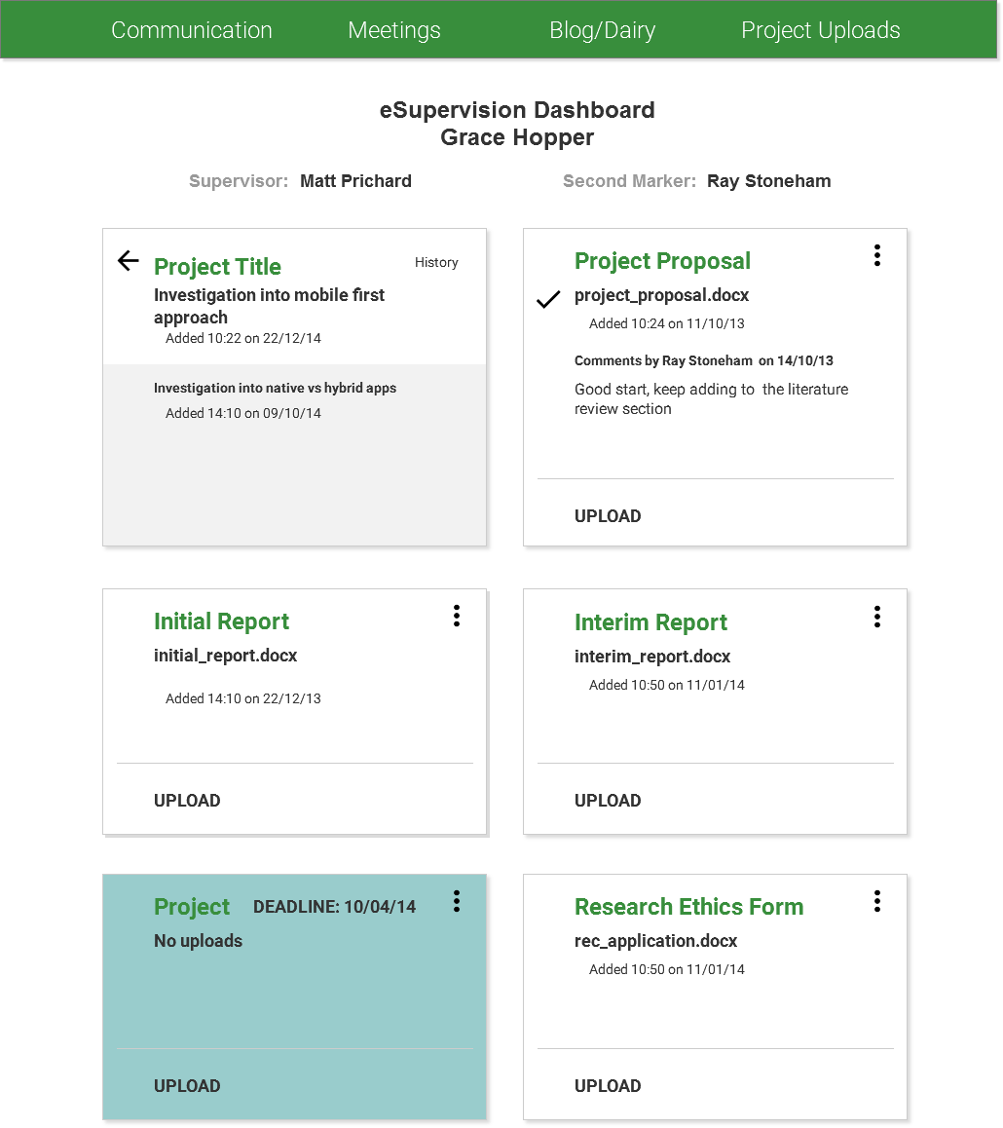

* + 1. More Info Uploads mobile

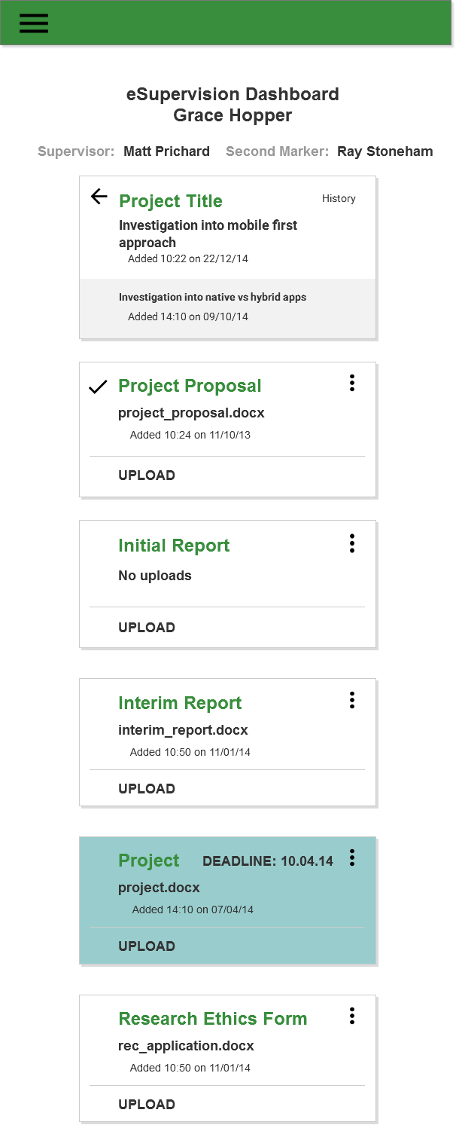

* + 1. Add Uploads tablet and desktop

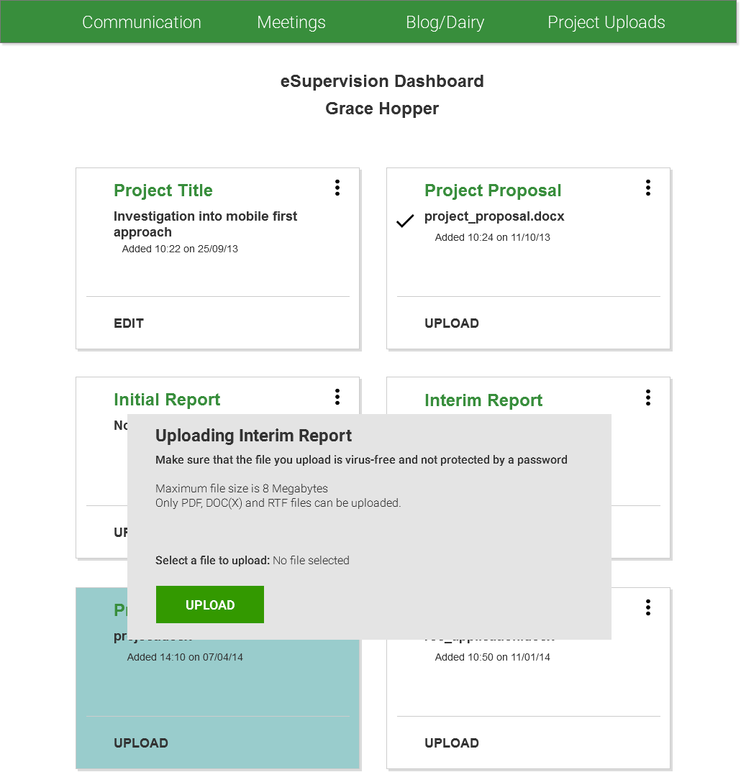

* + 1. Add Uploads mobile

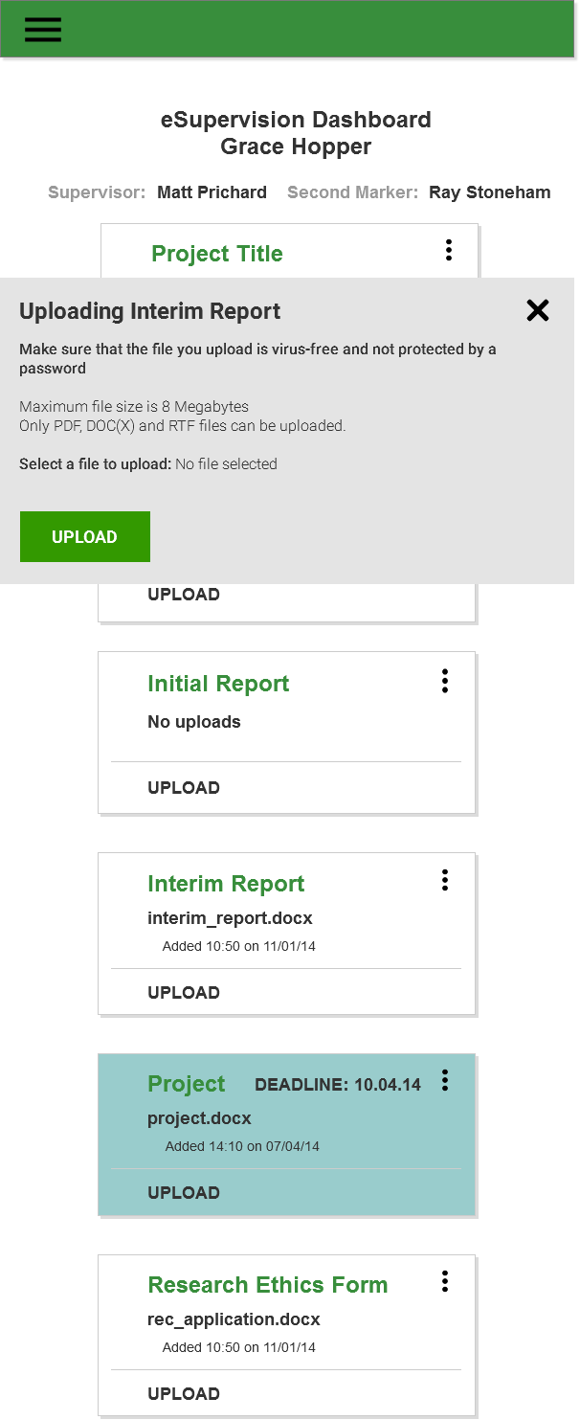

## Appendices

## Macintosh HD:Users:kinzan:Desktop:dig med tech:year3:term2:COMP1640EntWebSoftDev:cw1:group:desigher:sitemap:StudentSupervisor.pngAppendix A – Workflows by Kinza Naseer

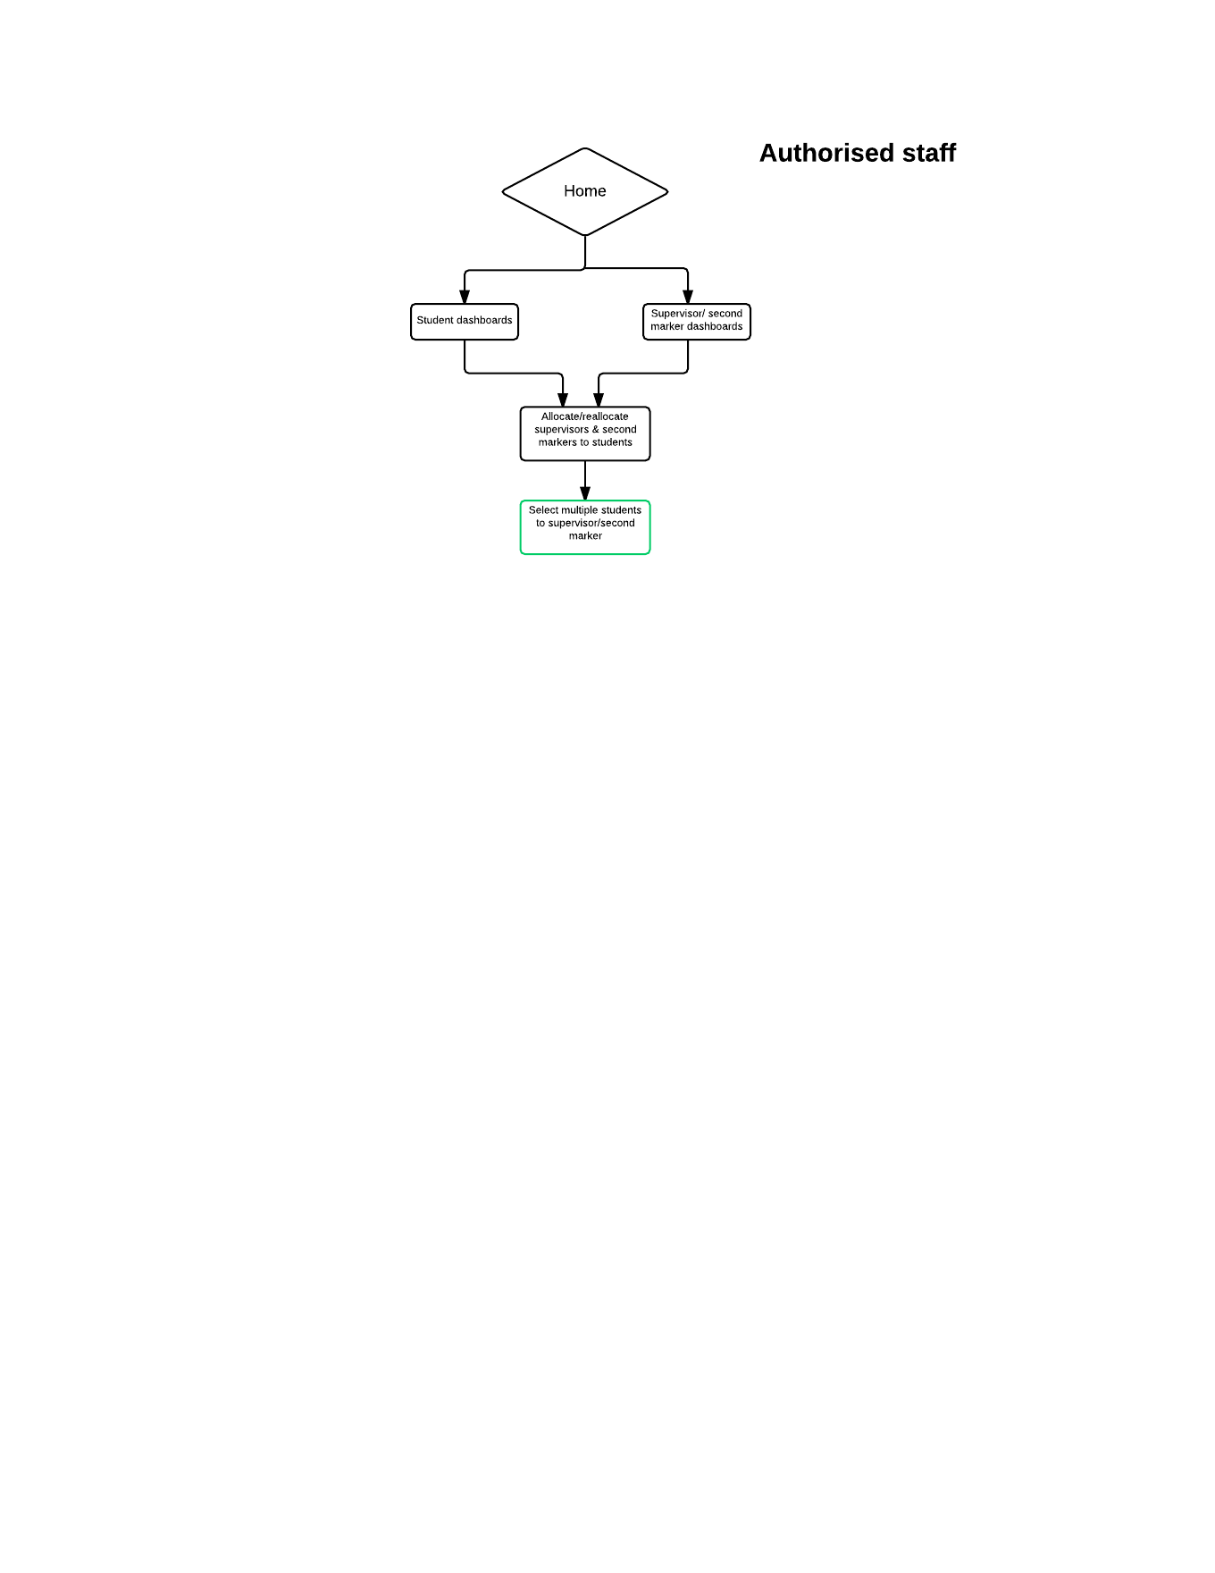

## Appendix B – Design Principles by Laura Whitehead

Design principles

Flat design

Emerging design style revolving around the use of rectangles, circles, and triangles with the absence of design elements such as gradients, shadows and strokes. This gives an easier to use to graphic user interface that is simpler, referring back to the two main principles flat design is based upon: readability and simplicity.

Example: Windows 8 Operating System (Brian LePore, 2013).

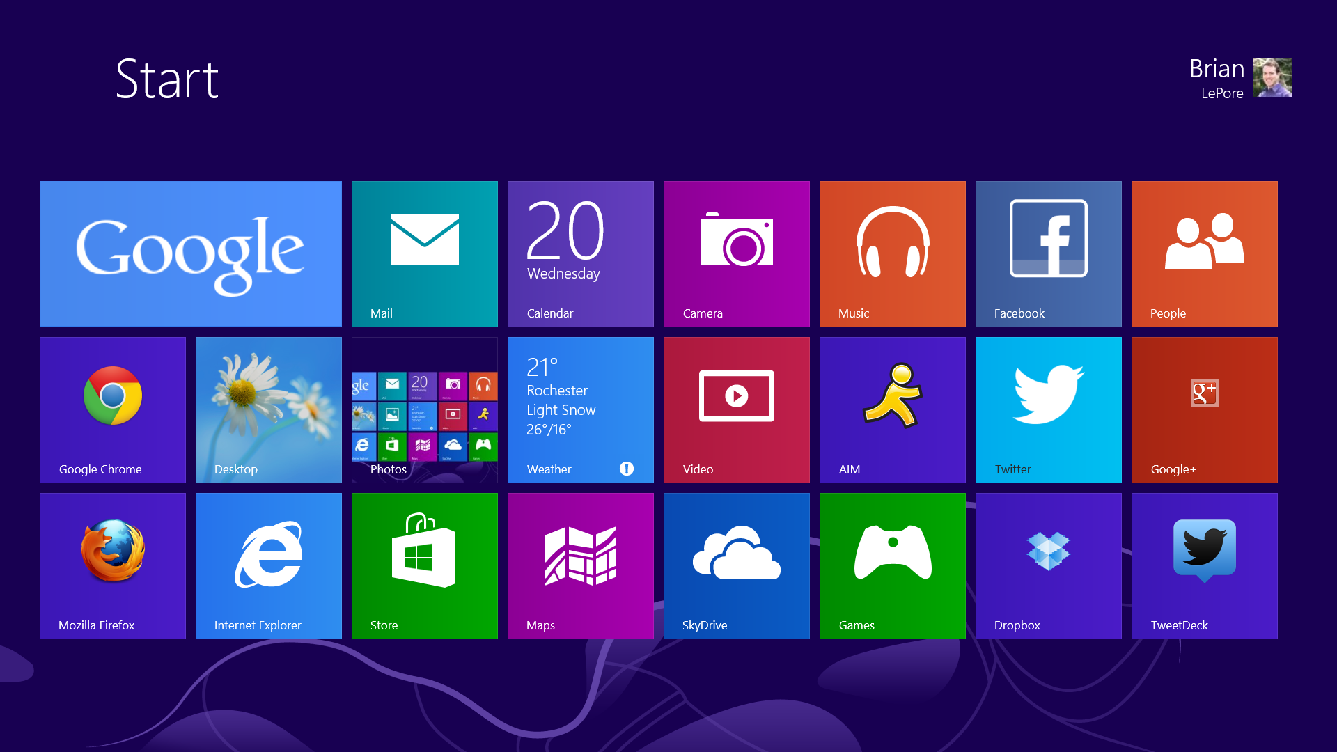

**Main Flat Design Principles**

**No Added Effects**

Gives flat design a distinct look

Reliance on a clear sense of hierarchy in the design and the appropriate placement of elements

More popular for smaller screens (app and mobile designs) as a flat interface is easier to use with fewer options

**Absence of depth**

Focuses on a simple 2D blueprint

Removes 3D element given by shadows, gradients and strokes

**Simple Elements**

Allowing for the shapes/content to stand alone

Each user interface element should be easy to click or tap and be simple

Intuitive interaction for users without the need for in-design explanation

**Focus on Typography**

Crisp and clear font texts with shorter messages and chromatically placed with color and shapes

Should tell users how to navigate the design by labeling elements such as buttons for increased interactivity and ease of use

**Focus on colour**

Contains more hues than in most colour palettes, sometimes up to six to eight colours equally

More vibrant colours, without any tones or tints applied

There is a trend in flat design of using retro colours such as salmon and vibrant purples, blues and greens

‘Candy’ colours are also popular as they can be contrasted and complemented easily with other colours.

**Minimalist Approach**

Less is more, de-clutter the screen

Gives padding and breathing room for your content

Material design

Material design is a design language that has been developed by Google. It is type of design with a larger use of responsive animations and transitions, depth effects such as shadows and lighting, and grid-based layouts.

The main goal of using material design is to ‘develop a single underlying system that allows for a unified experience across platforms and device sizes. Mobile precepts are fundamental, but touch, voice, mouse, and keyboard are all ﬁrst-class input methods’ (Google, 2014).

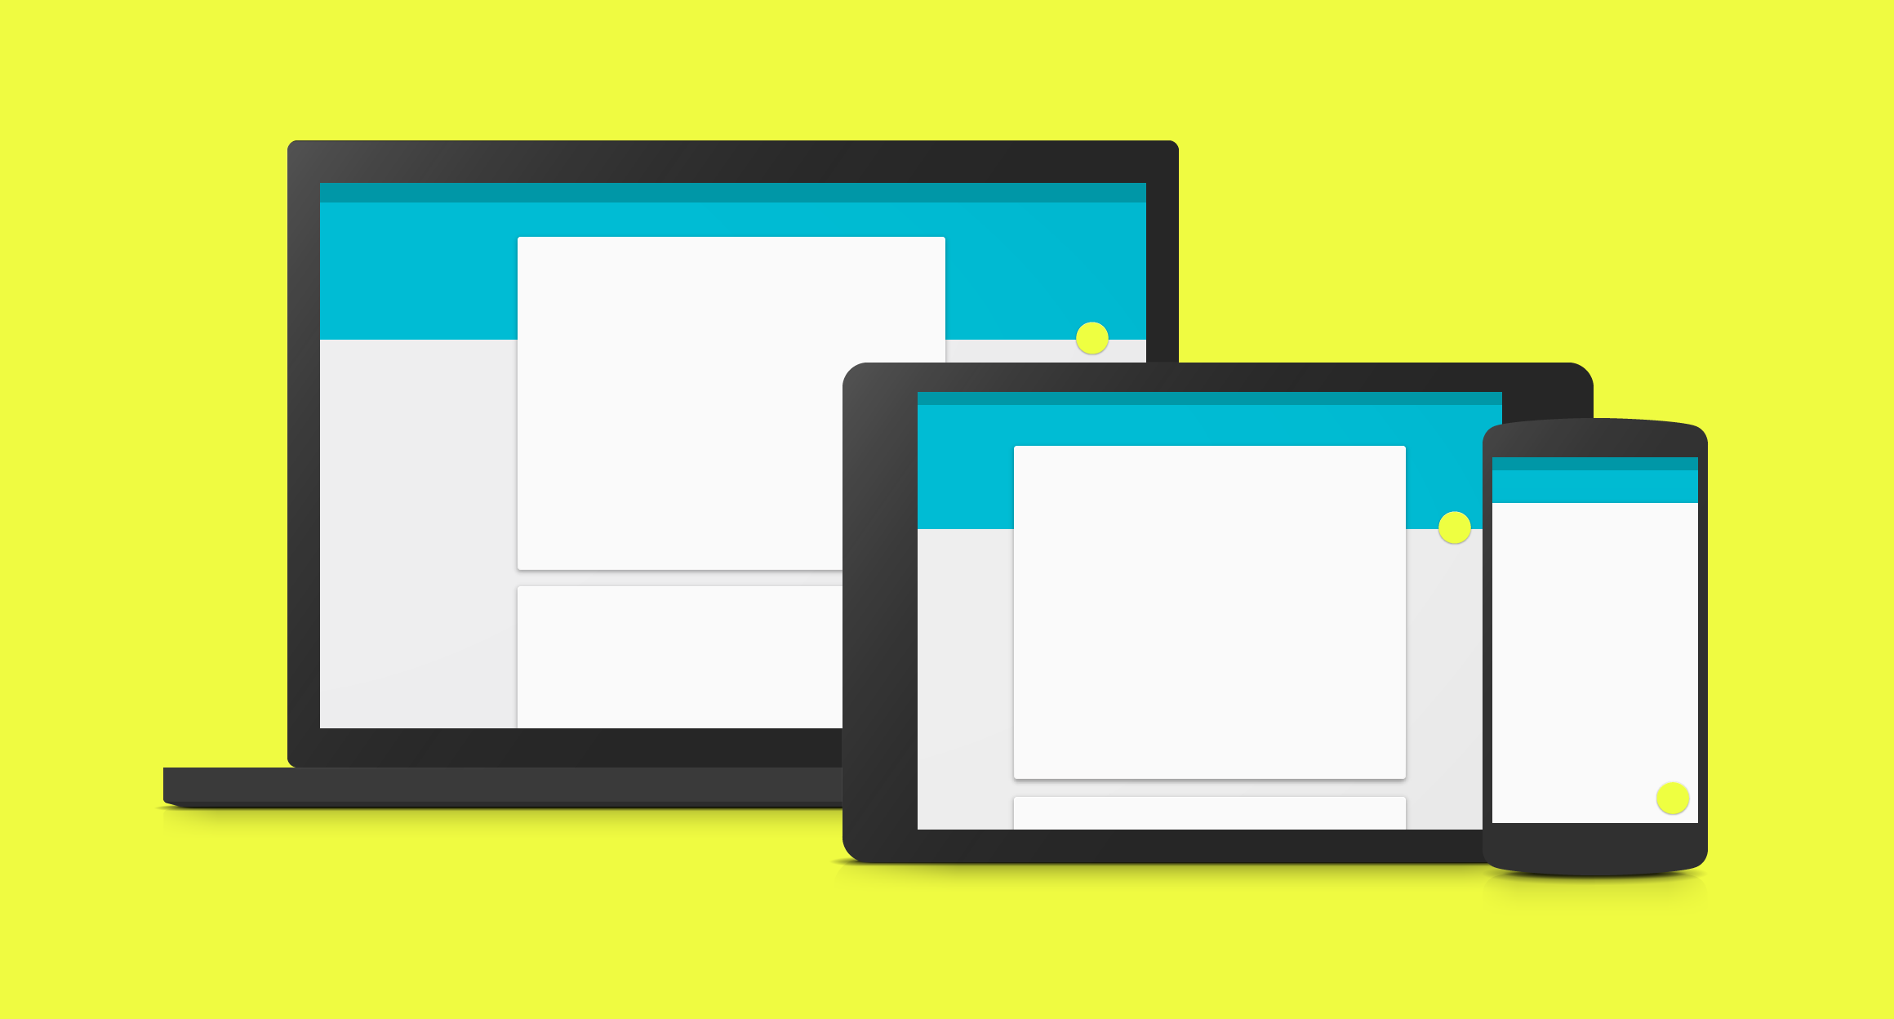

**Main Material Design Principles**

**Material is metaphor**

Material design is inspired by the study of paper and ink, yet is technologically advanced.

Edges and surfaces of the material are visual clues that are based in reality.

Light, surface and movement fundamentals are key to conveying how objects move, interact and exist is space and in relation to each other.

Realistic lighting shows seams, divides space, and indicates moving parts

**Bold, Graphic, and Intentional**

The foundational elements of print-based design: typography, grids, space, scale, colour, and use of imagery guide the user visually. These elements create hierarchy, meaning, and focus.

Deliberate color choices, edge-to-edge imagery, large-scale typography, and intentional white space create a bold and graphic interface that immerse the user in the experience.

An emphasis on user actions makes core functionality immediately apparent and provides waypoints for the user

**Motion provides meaning**

Motion respects and reinforces the user as the prime mover. Primary user actions are inflection points that initiate motion, transforming the whole design.

All action takes place in a single environment. Objects are presented to the user without breaking the continuity of experience even as they transform and reorganize.

Motion is meaningful and appropriate, serving to focus attention and maintain continuity. Feedback is subtle yet clear. Transitions are efﬁcient yet coherent

iOS DESIGN

Apple use three main themes for design: deference, clarity and depth.

Deference is how UI helps people understand and interact with the content, but never competes with it.

Clarity ensures all text is legible at every size, icons are precise and lucid, adornments are subtle and appropriate, and a sharpened focus on functionality motivates the design.

Finally, depth is how the visual layers and realistic motion impart vitality and heighten people’s delight and understanding.(iOS Developer Library, 2015)

**Main iOS Design Principles**

**Aesthetic Integrity**

Represents how well an app’s appearance and behavior integrates with its function to send a coherent message.

**Consistency**

Consistency lets users transfer their knowledge and skills from one part of an app’s UI to another and from one app to another app

**Direct Manipulation**

When people directly manipulate onscreen objects instead of using separate controls to manipulate them, they're more engaged with their task and it’s easier for them to understand the results of their actions.

**Feedback**

Feedback acknowledges people’s actions, shows them the results, and updates them on the progress of their task.

**Metaphors**

When virtual objects and actions in an app are metaphors for familiar experiences—whether these experiences are rooted in the real world or the digital world—users quickly grasp how to use the app.

It is best when an app uses a metaphor to suggest a usage or experience without letting the metaphor enforce the limitations of the object or action on which it is based.

**User Control**

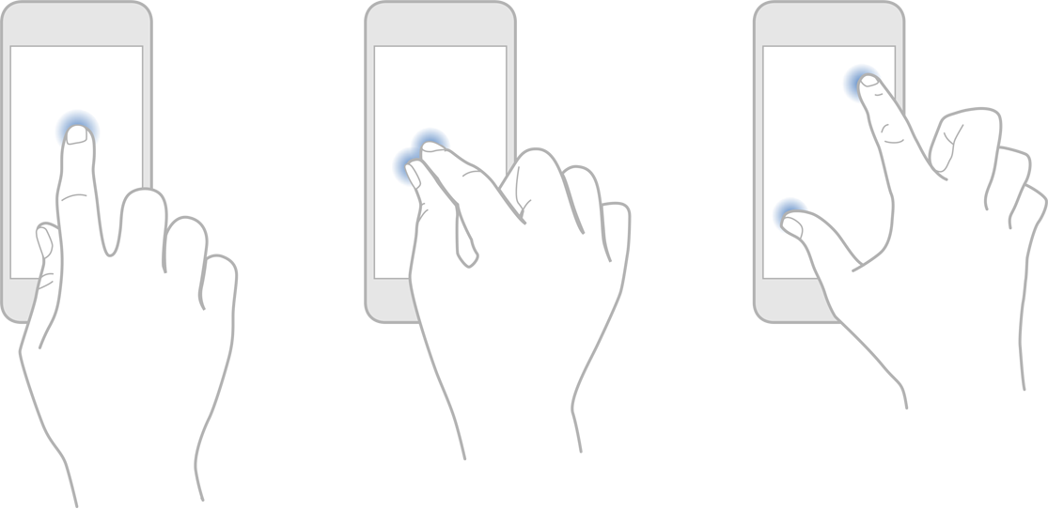

The users not the apps should initiate and control actions.

Users feel more in control of an app when behaviors and controls are familiar and predictable. And when actions are simple and straightforward, users can easily understand and remember them.

References / bibliography

Brian LePore. (2013). *Surface Pro Review.* Available: https://www.brandbuilderwebsites.com/blog/2013/02/22/surface-pro-review/. Last accessed 30/01/2015.

Google. (2014). Material Design. Available: http://www.google.co.uk/design/spec/material-design/introduction.html#introduction-principles. Last accessed 30/01/2015.

iOS Developer Library. (2015). *iOS Human Interface Guidelines.* Available: https://developer.apple.com/library/ios/documentation/UserExperience/Conceptual/MobileHIG/index.html. Last accessed 30/01/2015.

## Appendix C – Responsive Web Design by Andrew Tate

**Responsive Web**

Making a website responsive means it having the ability to chance the way it looks depending on the device and screen size that the user is viewing it from.

Making the website size fluid (using percentages to dictate the size of the page) can help to make websites look more attractive to more devices and get rid of horizontal scroll bars. However this could cause a problem if the site was not tested on multiple devices because the developer cannot see what the website looks like on every device (Knight, 2009).

With more devices being created such as mobile phones and tablets, websites need to be responsive so that users can easily access them. A website that is designed for a 13” laptop will most likely not look very appealing on a 4” mobile phone.

When creating a responsive website, start off designing the site for a mobile phone and then enlarge it later. There are procedures that a developer must go through to create a responsive website. On a smaller screen it is important to use the space that is available and decreasing the text size will help to save space and make the site look better (Kinlan, 2015).

Due to the size of mobiles devices, a traditional horizontal navigation display may not look as good as it does on a larger screen. Making a navigation bar that changes with the size of the screen can make websites more attractive. Example: <http://css-tricks.com/convert-menu-to-dropdown/>

Media queries allow developers to create a website that can apply a specific style based on the size of the users screen. An example of this is adding a ‘min-width’ query in the CSS code, this will allow the user to change how the website is displayed for browsers that is over the specified amount in the CSS code. I.e. min-width: 500px; any browser bigger than 500px will look a certain way. (Kinlan,

**Bootstrap**

Bootstrap is a front-end framework that developers can use to edit their websites. Bootstrap can be used with all major browsers. Bootstrap 3 has a mobile first grid system that makes creating mobile friendly websites and allows the websites to be displayed on different devices.

**Skeleton**

Like Bootstrap, Skeleton is a framework for websites but for small projects. Skeleton has built in features to make websites responsive alongside the other functionality that it offers its users. This includes buttons, lists, media queries and is all lightweight when it comes to code.

**Example:**



Figure 1: Twitter.com on a wide screen



Figure 2: Twitter.com on a reduced size screen

**References**

Getbootstrap.com,. 'Bootstrap · The World's Most Popular Mobile-First And Responsive Front-End Framework.'. N.p., 2015. Web. 1 Feb. 2015.

Getskeleton.com,. 'Skeleton: Responsive CSS Boilerplate'. N.p., 2015. Web. 2 Feb. 2015.

Kinlan, Paul. 'Make It Responsive — Web Fundamentals'. *Web Fundamentals*. N.p., 2014. Web. 1 Feb. 2015.(<https://developers.google.com/web/fundamentals/getting-started/your-first-multi-screen-site/responsive?hl=en>)

Knight, Kayla. 'Fixed Vs. Fluid Vs. Elastic Layout: What's The Right One For You? - Smashing Magazine'. *Smashing Magazine*. N.p., 2009. Web. 1 Feb. 2015.

**Biblography**

Knight, Kayla. 'Responsive Web Design: What It Is And How To Use It - Smashing Magazine'.*Smashing Magazine*. N.p., 2011. Web. 1 Feb. 2015.

## Appendix D - Initial wireframes by Kinza Naseer and Sumangalya Mohanarasa

**PC Wireframe for student dashboard**

The design will scale down accordingly when viewed on a Mobile & Tablet

**\*NOTE: RED UNDERLINED TEXT IN WIREFRAME SIGNIFIES A LINK\***

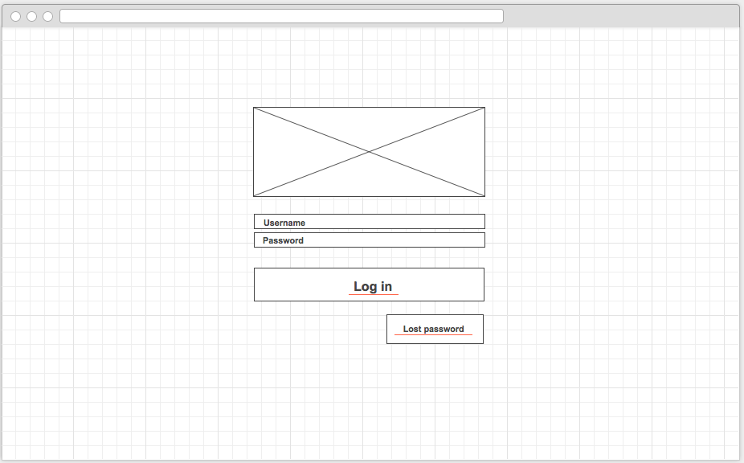**Log in**

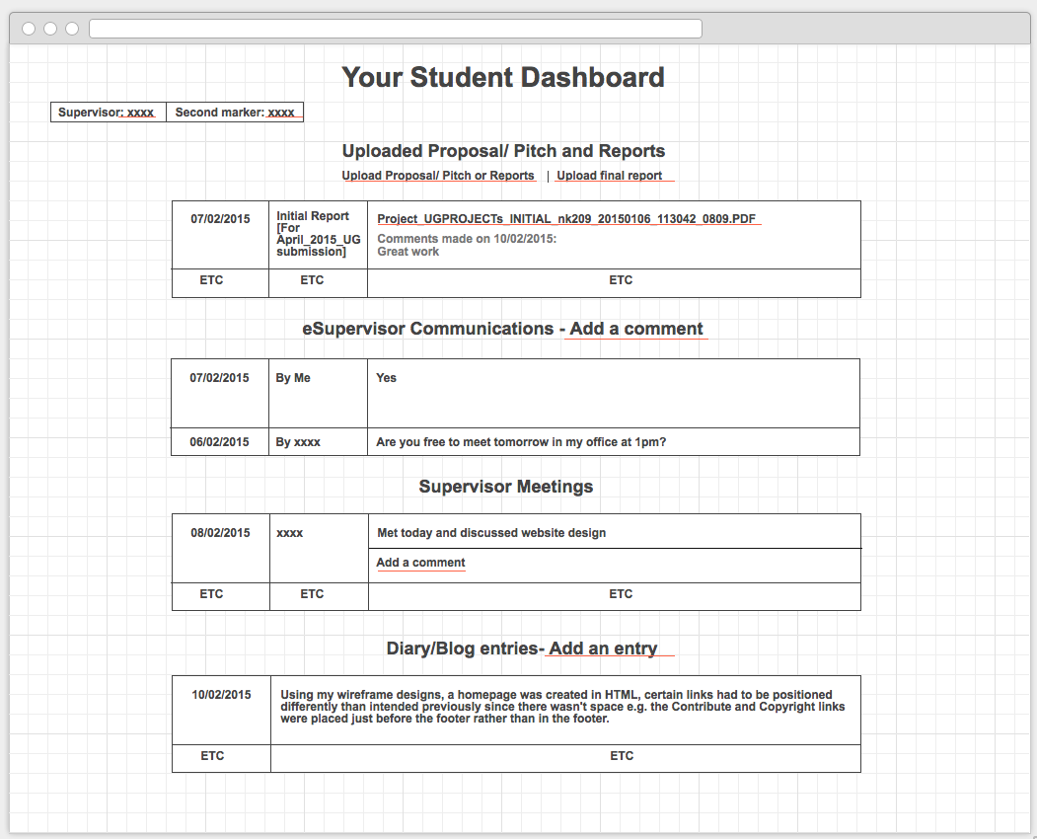**Student home**

Canvas: 1034/799px**Supervisor profile**   
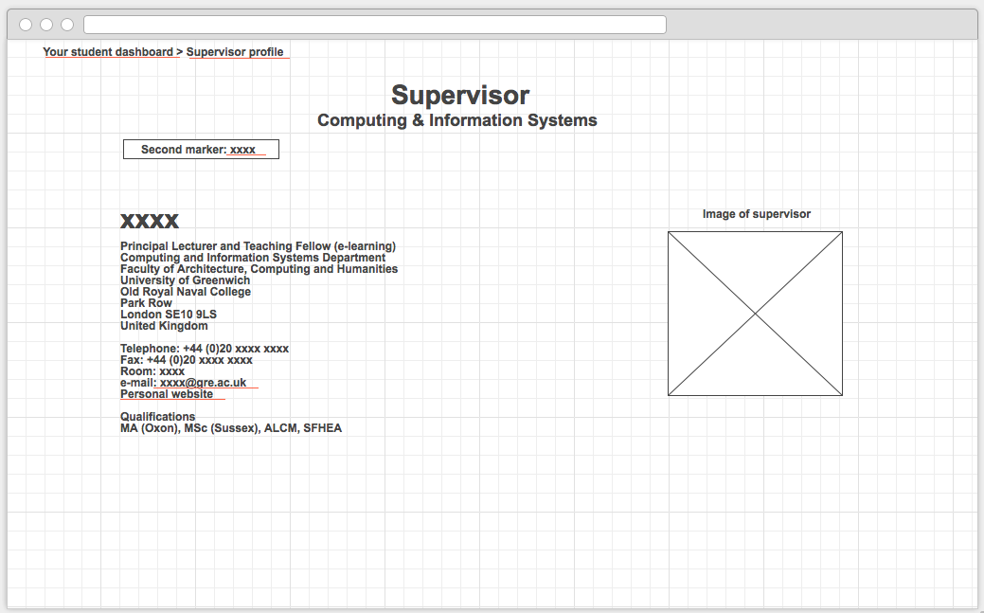  
  
  
  
  
  
  
  
  
  
  
  
  
  
  
  
  
  
  
  
Canvas: 1024/600px  
  
  
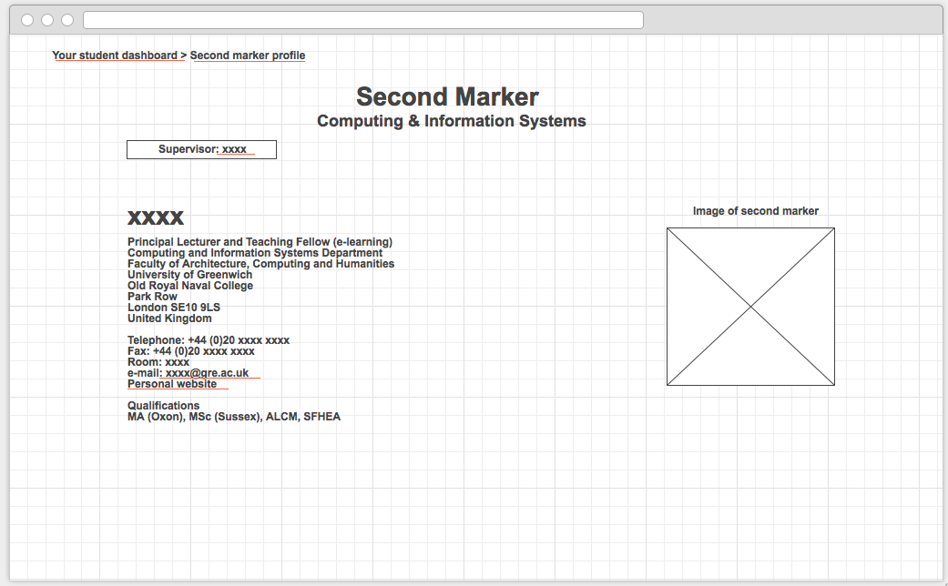**Second marker profile   
  
  
  
  
  
  
  
  
  
  
  
  
  
  
  
  
  
Canvas: 1024/600pxUpload documents**   
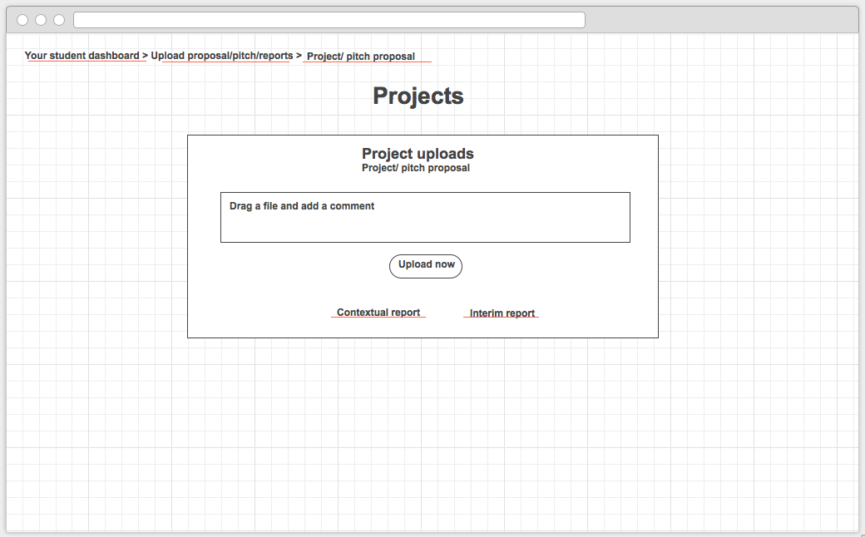

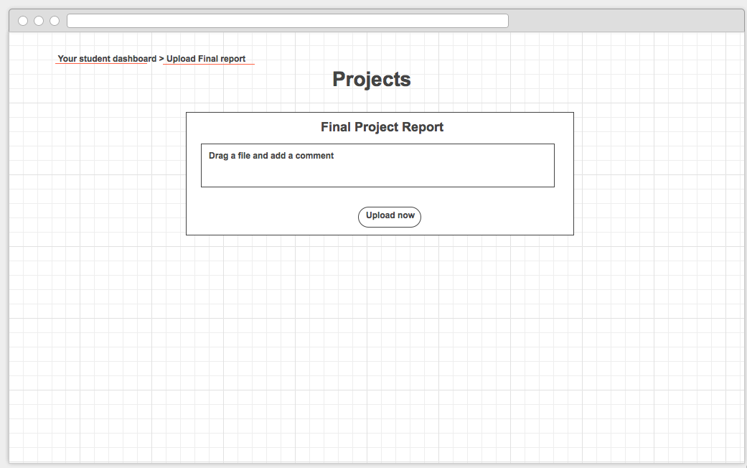Canvas: 1024/600px  
  
  
  
  
  
  
  
  
  
  
  
  
  
  
  
  
  
  
  
Canvas: 1024/600px**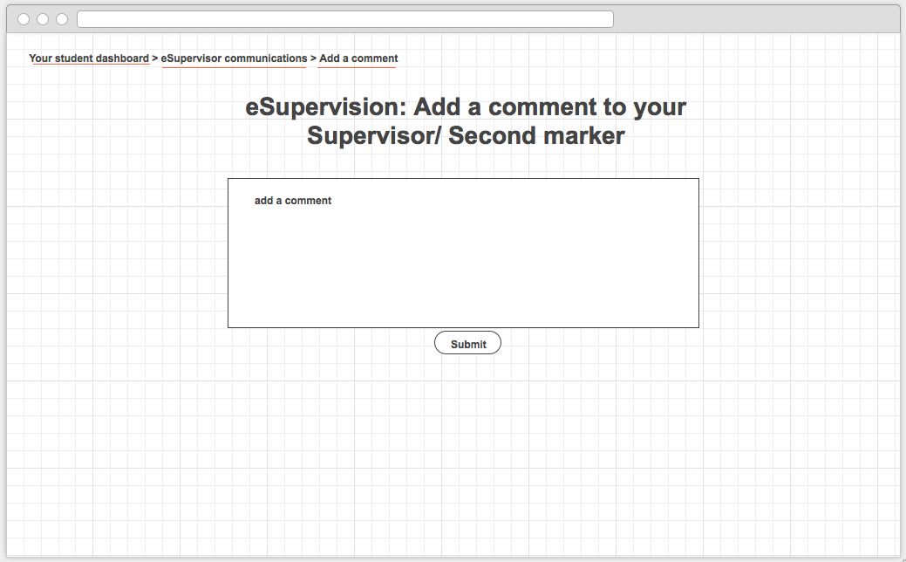E-supervisor communications**Canvas: 1024/600px

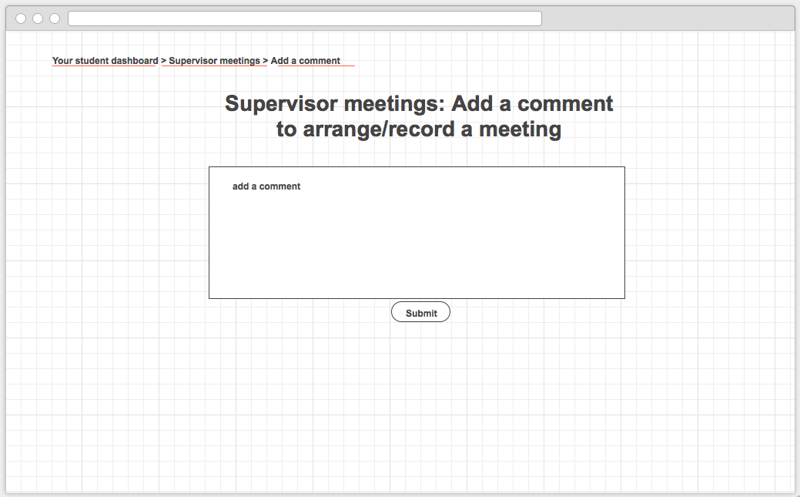**Supervisor meetings**Canvas: 1024/600px

Diary/ blog

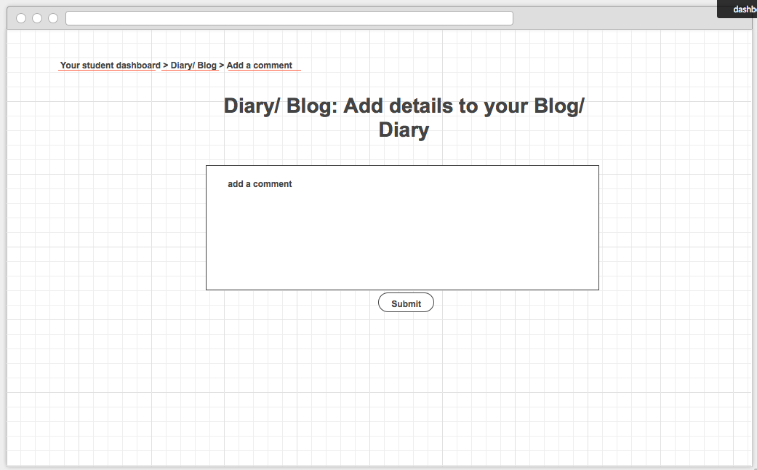

Canvas: 1024/600px

Supervisor/second marker

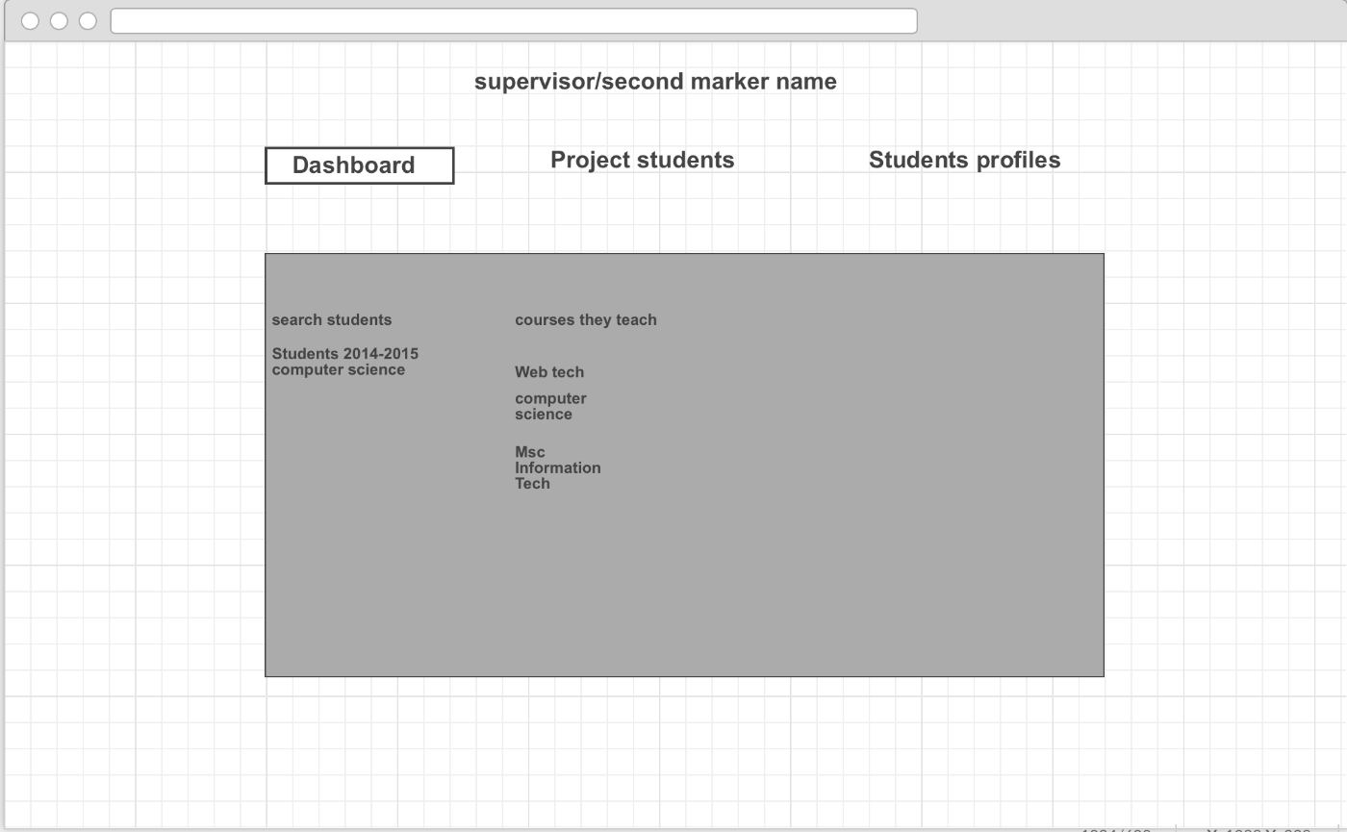

Authorized would be allowed to view all the supervisors/ second markers dashboard. They can edit their project students, by going into project students tab.

Authorized staff would be allowed project students, and edit it.

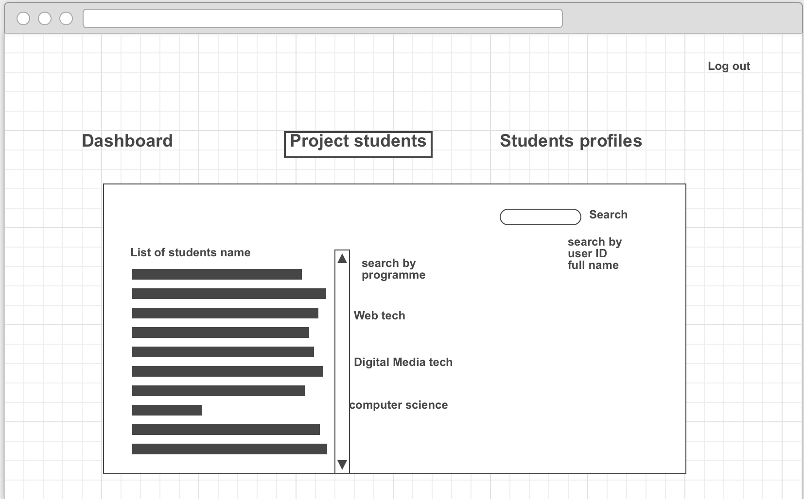

Authorized staff and click onto the students and edit their supervisors.

Student name

Edit

Supervisor Name : Matt

List of supervisors name:

Authorized staff clicks onto the name and it would change automatically.

## Appendix E – Initial prototype by Kinza Naseer

**Student dashboard: Browser**

Design guidelines

Palette

Chosen: Material design

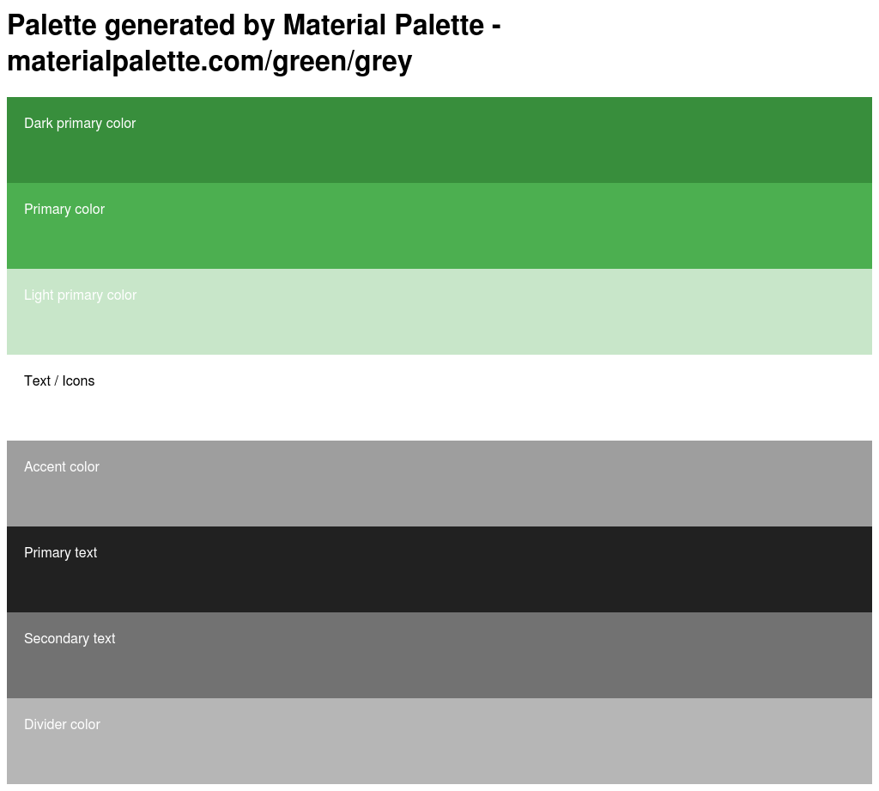Palette will be based on two colours; Green and Grey. Below are the colours to use with each element along with its CSS.  
  
  
  
  
  
  
  
  
  
  
  
  
  
  
  
  
  
  
  
  
  
  
  
  
  
  
CSS

.dark-primary-color { background: #388E3C; }

.default-primary-color { background: #4CAF50; }

.light-primary-color { background: #C8E6C9; }

.text-primary-color { color: #FFFFFF; }

.accent-color { background: #9E9E9E; }

.primary-text-color { color: #212121; }

.secondary-text-color { color: #727272; }

.divider-color { border-color: #B6B6B6; }

Typography

Font name: Roboto

A folder containing the font is included on GitHub: directory is: GreenwichCodeZero/Documentation>Design>Typography.

Alternatively fonts can be downloaded from:

[www.materializecss.com/typography.html](http://www.materializecss.com/typography.html)

Font weights

Roboto has six weights: Thin, Light, Regular, Medium, Bold, and Black, these are included on GitHub (follow directory above).

Browser size

Chosen size is **1024px by 768px**

Prototypes

Student Dashboard

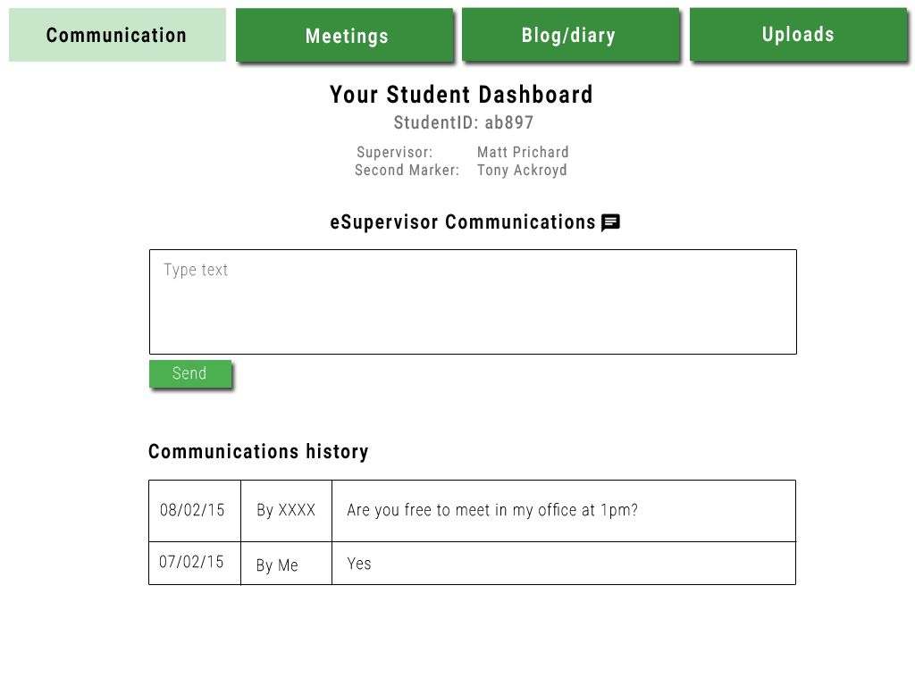

**Navigation**

The navigation consists of raised buttons to draw more attention to them. I based this on the material design guidelines. [http://www.google.co.uk/design/spec/components/buttons.html#](http://www.google.co.uk/design/spec/components/buttons.html)

Text size: 40px

Text colour: #FFFFFF

Font: Roboto bold

Button colour:#388E3C

Hovered button colour: #C8E6C9

Hovered text colour: #000000**Headings**

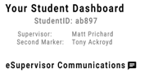Font: Roboto Bold

Size: 48px

  
  
Font: Roboto Medium

Size: 36px  
  
  
Font: Roboto Regular

Size: 30px  
  
  
Font: Roboto Bold

:studentDashPro:snaps:home:Communicaionshist.pngSize: 40px

Font: Roboto Bold

Size: 40px

:icons:CHAT.png**icons/buttons**Obtained from Material icons site: <https://google.github.io/material-design-icons/>:studentDashPro:snaps:home:shapes:Send.pngFont: Roboto thin

Size: 32px

Text colour: #FFFFFF

Rectangle width: 92px

Rectangle height: 31px

Background colour: #4CAF50

**Tables**

All tables/ text fields on the Communication, Blog and Uploads pages have a width as displayed below. The height will vary on how much text the student inputs. The height below is for the image below which is on the **communications** page.

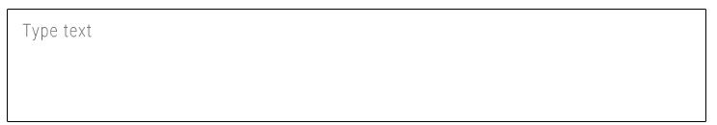  
  
  
  
  
  
Rectangle width: 723px

Rectangle height: 116px

Font: Roboto thin

Text size: 32px

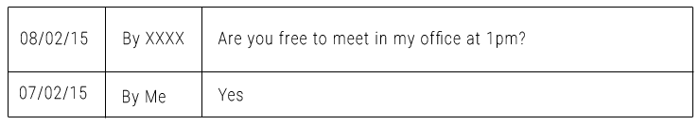Text colour: #727272

Font: Roboto thin

Text size: 32px

Text colour: #000000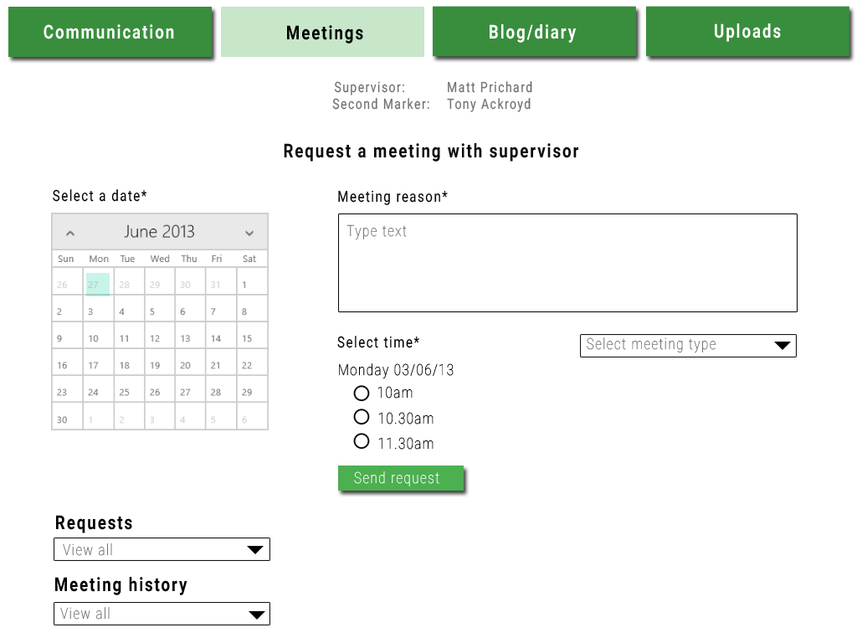Meetings  
  
  
  
  
  
  
  
  
  
  
  
  
  
  
  
  
  
  
  
  
  
  
  
  
  
**Note: Navigation, supervisor/second marker and main heading specifications can be found above.**

This will be a Calendar GUI.

Font: Roboto Regular  
Font size: 32px  
Colour: #000000

Font: Roboto thin  
Font size: 32px  
Colour: #727272

:icons:dropdown.png  
  
Obtained from Material icons site: <https://google.github.io/material-design-icons/>

:icons:radioOff.png   
  
Obtained from Material icons site: <https://google.github.io/material-design-icons/>

Font: Roboto thin  
Size: 32px  
Text colour: #FFFFFF  
Rectangle width: 92px  
Rectangle height: 31px  
Background colour: #4CAF50

Font: Roboto Bold  
Size: 40px  
Text colour: #000000

Blog/ Diary  
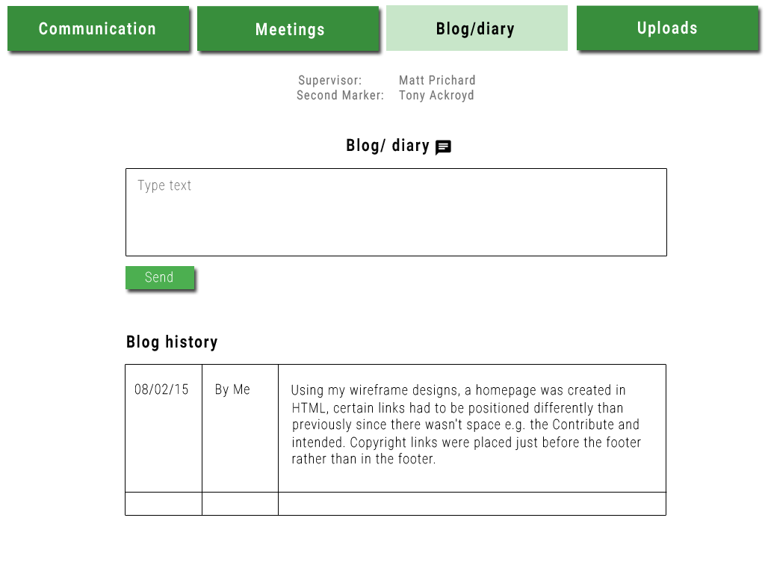

**See specification above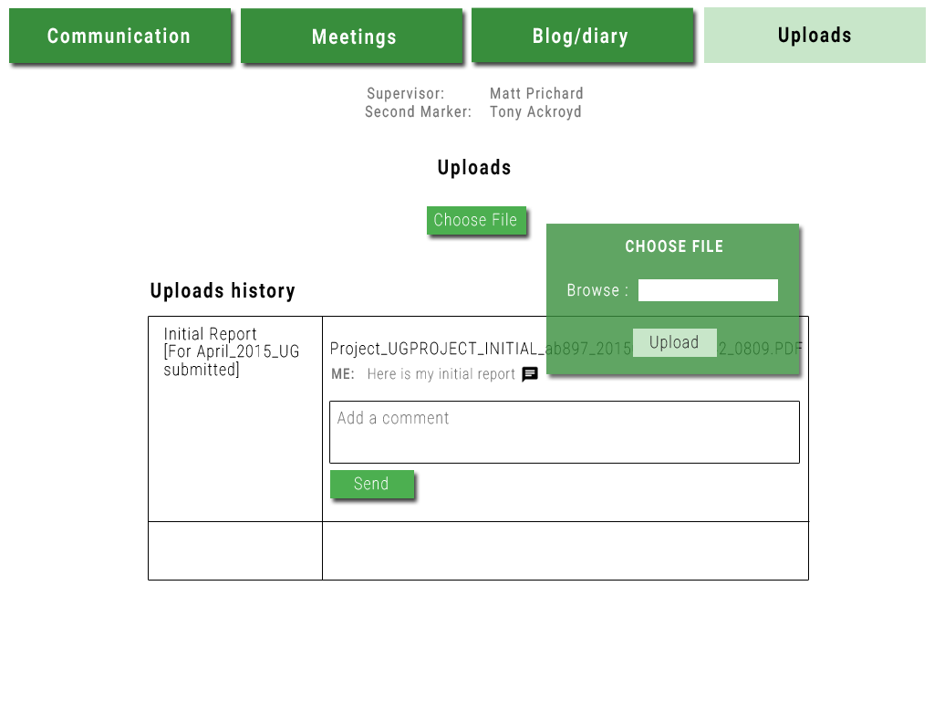**Uploads8. Font: Roboto Thin

Font-Size: 32px  
 Colour: #FFFFFF  
 Rectangle width: 109px  
 Rectangle height: 31px  
 Background colour: #4CAF50

9. Font: Roboto Bold   
 Font size: 32px  
 Text colour: #FFFFFF

10.   
  
  
 Text size: 32px  
 Font: Roboto Light

Text colour: #FFFFFF

11. Rectangle width: 92px  
 Rectangle height: 31px

Text colour: #000000

Font: Roboto Thin

Font size: 32px

12. Box colour: #4CAF50 Opacity: 80%  
 Box width: 277px

Box height: 165px